# Spring Certification Module 8 -Testing

# Question 01 – Do you use Spring in a unit test?

Spring Framework is usually not used in unit tests, however Spring contains some support for unit testing within following packages:

* org.springframework.test.util
  + ReflectionTestUtils
    - ORM Entities related testing–set value for private field, normally handled by ORM
    - Manual dependency injection into private field, normally handled by @Autowired, @Inject
    - @PostConstruct and @PreDestroy lifecycle callback methods testing
  + AopTestUtils–Aspect Oriented Programming Related Testing
* org.springframework.test.web
  + ModelAndViewAssert–Unit Testing for Spring MVC Controllers
* org.springframework.mock.env
  + mock implementations of the Environment and PropertySource
  + MockEnvironment, MockPropertySource
* org.springframework.mock.jndi
  + Mock implementation of JNDI SPI–usually used for JavaEE
* org.springframework.mock.web
  + Servlet API mock objects

To get full understanding on why Spring is usually not used for unit tests, however some support for unit testing exists within framework, we need to get deeper into testing subject and understand differences between:

* UnitTests
* IntegrationTests
* SystemTests

Having understanding on purpose and range of testing performed on each level will make it clear to know at which type of test Spring IoC/DI should be used and at which level only Spring Mocks should be used, without involving Spring IoC/DI.

## Unit Tests

Unit Tests should test one **unit of functionality** in **isolation**. This unit of functionality can be defined as **single** method, **class**, module, component. In **Object Oriented Programming**, **unit of functionality is usually defined as single class**. Testing in isolation, means that environment of execution is not initiated during testing and should not affect testing process, any dependencies on environment should be mocked. All **class collaborators should be mocked** as well. Testing should be performed **outside of container**, that means that **IoC/DI should not be required to create instances** of objects undertest. Tests should execute successfully as out-of-container tests.

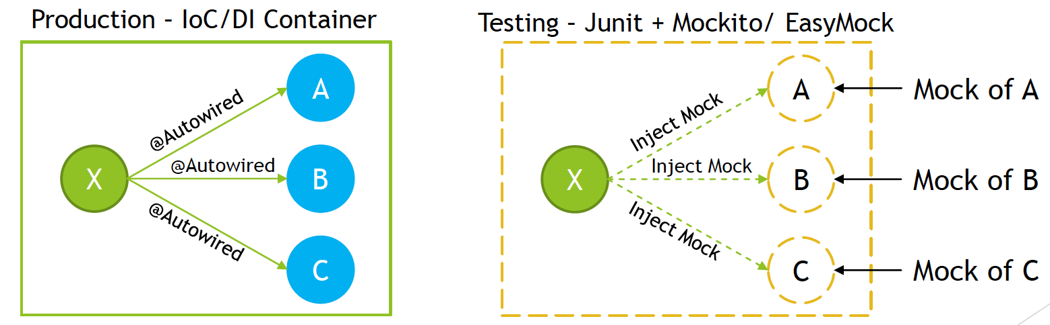

## Integration Tests

Integration Tests should test **multiple** modules or **components** that are **combined together**. Those modules should be already unit tested, and on Integration Test level some subset of functionalities should be checked, to test if modules provide requested functionalities when cooperating together under environment that should be close to production one, however with assumptions **that some of components might still be mocked**. When performing Integration Test we want to **initiate subset of system** and execute test against it. **IoC/DI Container is used** for this kind of testing, with some simplification upon deployment or container execution.

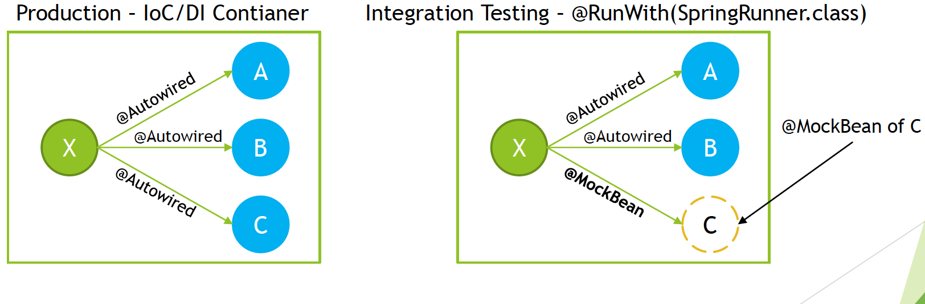

## System Tests

System Tests should check required system functionality on fully running system, consisting of all modules and environment that is as close as possible to production one. System under System Tests level should already be checked on unit and integration test level, and on System level only subset of functionalities should be checked to fill the gaps that were not possible to test on unit and integration testing level. IoC/DI container is used with assumption that it is used in the same way as production environment.

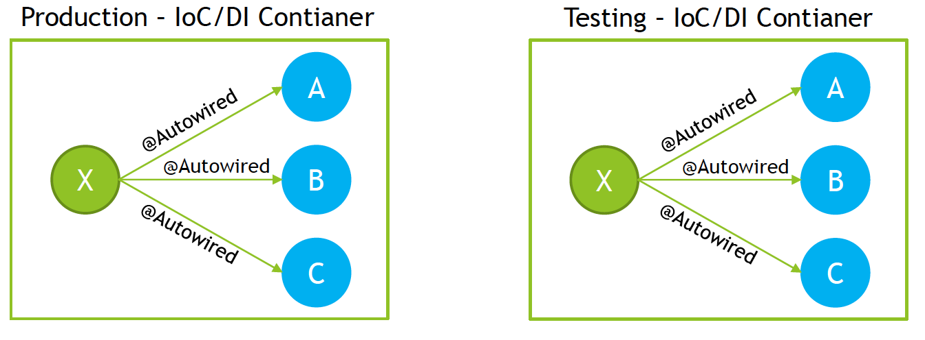

In practice, large scale enterprise systems needs to have testing strategy defined to test system that is being developed in efficient manner Often used strategy for test automation is “Testing Pyramid” It assumes that Unit, Integration and System Tests are implemented, with right ratio on number of tests on each level

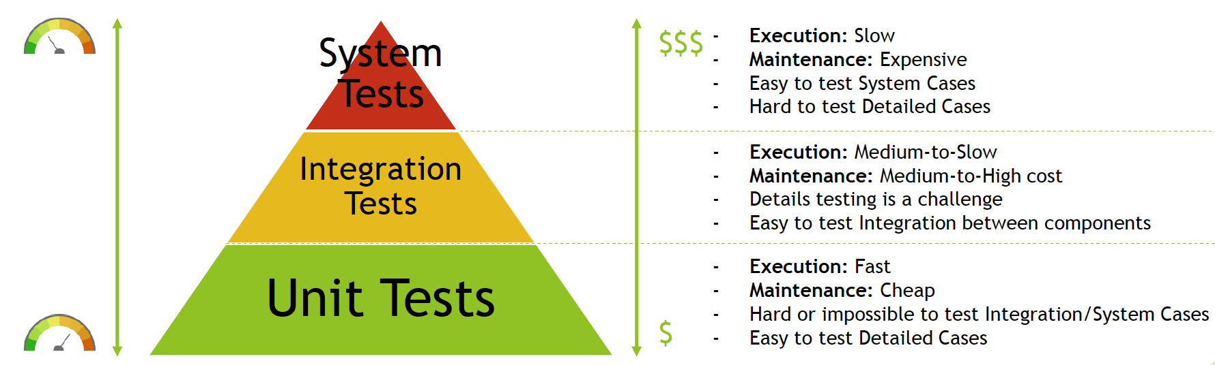

On each level right set of tools should be used to perform testing, minimize costs and maximize feedback from automated tests

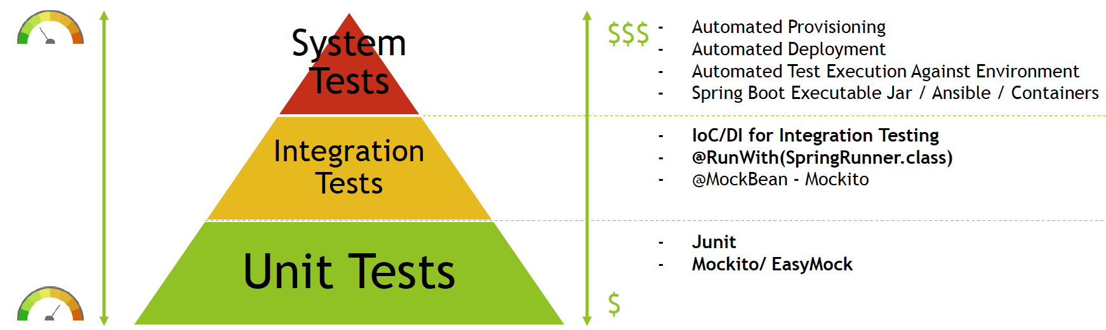

In large scale projects, you need to have all types of tests implemented, as on each level you can look at different level of details of the system.

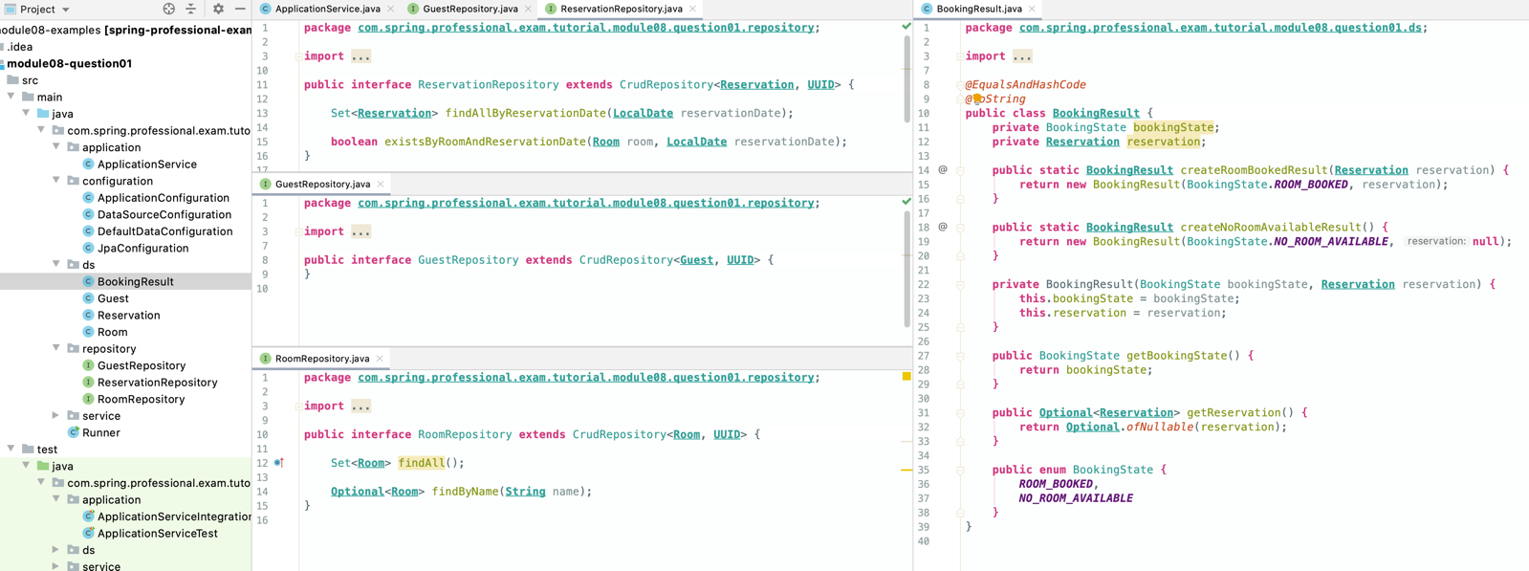

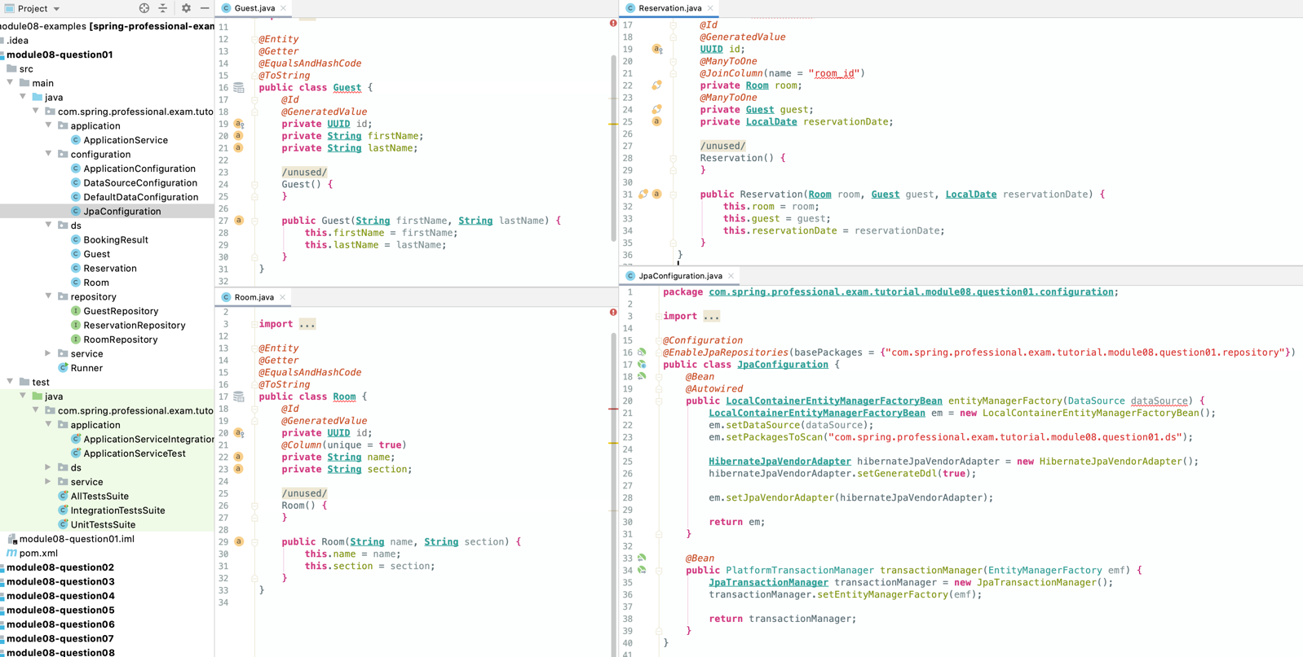

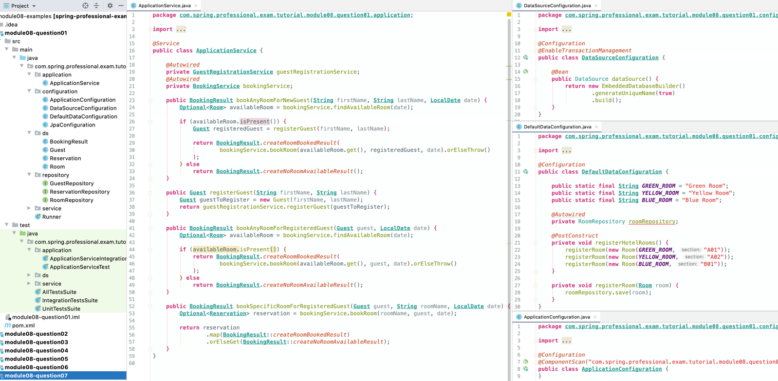

**public class Runner** {  
 **public static void** main(**String**[] args) *{* **AnnotationConfigApplicationContext** context = **new** AnnotationConfigApplicationContext(**ApplicationConfiguration**.**class**);  
 context.registerShutdownHook();  
  
 **ApplicationService** applicationService = context.getBean(**ApplicationService**.**class**);  
  
 **BookingResult** bookingResult1 = applicationService.bookAnyRoomForNewGuest("John", "Doe", **LocalDate**.*of(*2020, Month.***JULY***, 20*)*);  
 **System**.***out***.println("Booking Result for John Doe at 7/20/2020 is " + bookingResult1);  
  
 **BookingResult** bookingResult2 = applicationService.bookAnyRoomForNewGuest("Nora", "Knight", **LocalDate**.*of(*2020, Month.***JULY***, 20*)*);  
 **System**.***out***.println("Booking Result for Nora Knight at 7/20/2020 is " + bookingResult2);  
  
 **BookingResult** bookingResult3 = applicationService.bookAnyRoomForNewGuest("Ainsley", "Jensen", **LocalDate**.*of(*2020, Month.***JULY***, 20*)*);  
 **System**.***out***.println("Booking Result for Ainsley Jensen at 7/20/2020 is " + bookingResult3);  
  
 **BookingResult** bookingResult4 = applicationService.bookAnyRoomForNewGuest("Vance", "Woodward", **LocalDate**.*of(*2020, Month.***JULY***, 20*)*);  
 **System**.***out***.println("Booking Result for Vance Woodward at 7/20/2020 is " + bookingResult4);  
  
 **BookingResult** bookingResult5 = applicationService.bookAnyRoomForNewGuest("Vance", "Woodward", **LocalDate**.*of(*2020, Month.***JULY***, 21*)*);  
 **System**.***out***.println("Booking Result for Vance Woodward at 7/21/2020 is " + bookingResult5);  
  
 **Guest** guest = applicationService.registerGuest("Milo", "Steele");  
 **System**.***out***.println("Milo Steele registered as " + guest);  
 **BookingResult** bookingResult6 = applicationService.bookAnyRoomForRegisteredGuest(guest, **LocalDate**.*of(*2020, Month.***JULY***, 21*)*);  
 **System**.***out***.println("Booking Result for already registered guest Milo Steele at 7/21/2020 is " + bookingResult6);  
  
 **BookingResult** bookingResult7 = applicationService.bookSpecificRoomForRegisteredGuest(guest, "Yellow Room", **LocalDate**.*of(*2020, Month.***JULY***, 21*)*);  
 **System**.***out***.println("Booking Result for specific room for already registered guest Milo Steele at 7/21/2020 is " + bookingResult7);  
 *}*}

### Tests

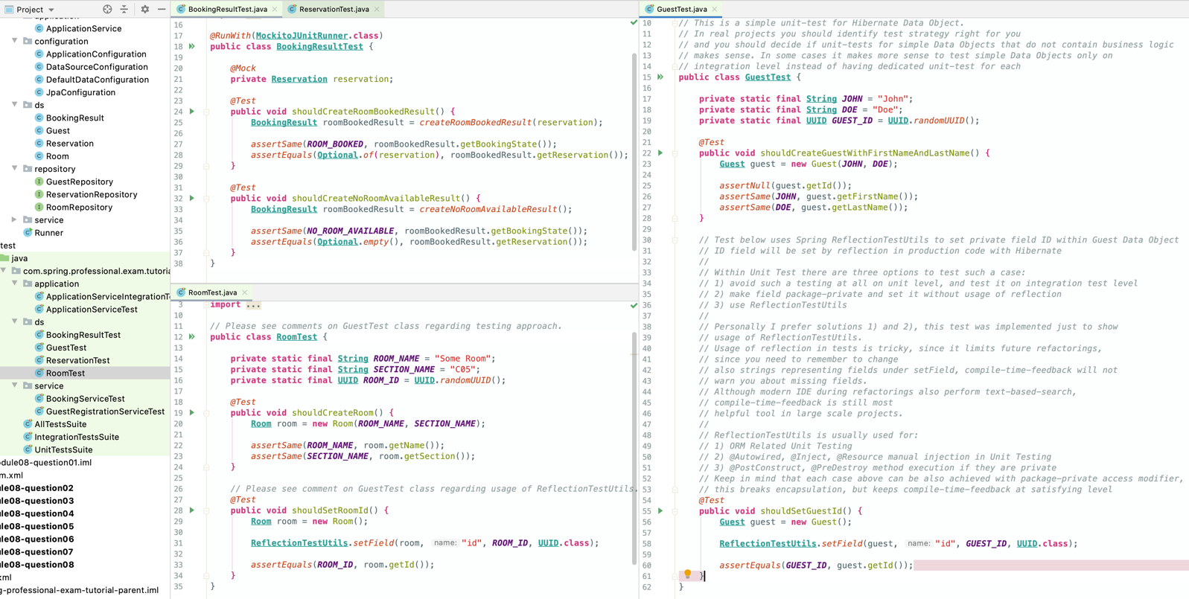

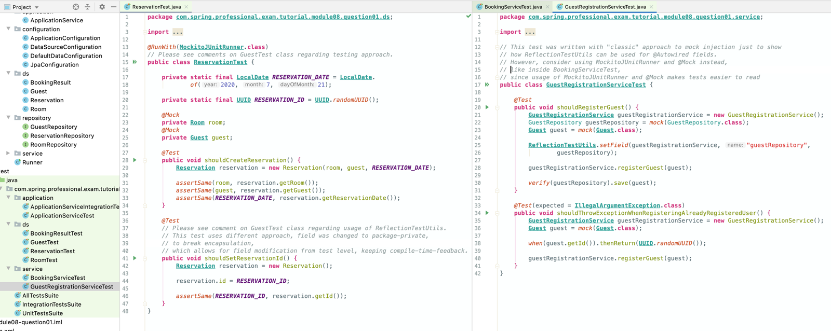

*@ExtendWith*(**MockitoExtension**.**class**)for junit5

*@RunWith*(**MockitoJUnitRunner**.**class**) for junit 4  
**public class BookingServiceTest** {  
  
 **private static final LocalDate *DATE*** = **LocalDate**.*of*(2020, 7, 21);  
 **private static final LocalDate *DIFFERENT_DATE*** = **LocalDate**.*of*(2020, 7, 22);  
 **private static final String *ROOM_NAME*** = "SOME_ROOM";  
 **private static final String *DIFFERENT_ROOM_NAME*** = "DIFFERENT_ROOM_NAME";  
  
 *@InjectMocks* **private BookingService** bookingService;  
 *@Mock* **private** ReservationRepository reservationRepository;  
 *@Mock* **private** RoomRepository roomRepository;  
 *@Mock* **private Room** room1;  
 *@Mock* **private Room** room2;  
 *@Mock* **private Room** room3;  
 *@Mock* **private Guest** guest;  
 *@Mock* **private Reservation** reservation;  
  
 *@Test* **public void** shouldFindAvailableRoomAtDateWhenAllRoomsAvailable() *{* mockRooms(room1, room2, room3);  
 mockNoRoomsReservedAtDate(***DATE***);  
  
 **Optional**<**Room**> availableRoom = bookingService.findAvailableRoom(***DATE***);  
  
 *assertTrue*(availableRoom.isPresent());  
 *assertThat*(availableRoom.get())  
 .isIn(room1, room2, room3);  
 *}  
  
 @Test* **public void** shouldFindLastRoomWhenAllOthersAreReserved() *{* mockRooms(room1, room2, room3);  
 mockRoomsReservedAtDate(***DATE***, room1, room2);  
  
 **Optional**<**Room**> availableRoom = bookingService.findAvailableRoom(***DATE***);  
  
 *assertTrue*(availableRoom.isPresent());  
 *assertSame*(room3, availableRoom.get());  
 *}  
  
 @Test* **public void** shouldFindRoomWhenAllReservedButOnDifferentDate() *{* mockRooms(room1, room2, room3);  
 mockRoomsReservedAtDate(***DIFFERENT_DATE***, room1, room2, room3);  
  
 **Optional**<**Room**> availableRoom = bookingService.findAvailableRoom(***DATE***);  
  
 *assertTrue*(availableRoom.isPresent());  
 *assertThat*(availableRoom.get())  
 .isIn(room1, room2, room3);  
 *}  
  
 @Test* **public void** shouldNotFindRoomWhenAllReserved() *{* mockRooms(room1, room2, room3);  
 mockRoomsReservedAtDate(***DATE***, room1, room2, room3);  
  
 **Optional**<**Room**> availableRoom = bookingService.findAvailableRoom(***DATE***);  
  
 *assertFalse*(availableRoom.isPresent());  
 *}  
  
 @Test* **public void** shouldReserveRoomByNameForGuestAtDate() *{* mockRoomSearchByName(***ROOM_NAME***, room1);  
 mockReservationDoesNotExistsForRoomAtDate(room1, ***DATE***);  
 mockReservationSaved(room1, guest, ***DATE***, reservation);  
  
 **Optional**<**Reservation**> reservationResult = bookingService.bookRoom(***ROOM_NAME***, guest, ***DATE***);  
  
 *assertTrue*(reservationResult.isPresent());  
 *assertSame*(reservation, reservationResult.get());  
 *}  
  
 @Test* **public void** shouldNotReserveRoomByNameWhenRoomAlreadyReserved() *{* mockRoomSearchByName(***ROOM_NAME***, room1);  
 mockReservationExistsForRoomAtDate(room1, ***DATE***);  
  
 **Optional**<**Reservation**> reservationResult = bookingService.bookRoom(***ROOM_NAME***, guest, ***DATE***);  
  
 verifyReservationNotSaved();  
  
 *assertFalse*(reservationResult.isPresent());  
 *}  
  
 @Test*(expected = **NoSuchElementException**.**class**)  
 **public void** shouldThrowExceptionWhenRoomByNameNotFound() *{* mockRoomSearchByName(***ROOM_NAME***, room1);  
  
 bookingService.bookRoom(***DIFFERENT_ROOM_NAME***, guest, ***DATE***);  
 *}  
  
 @Test* **public void** shouldReserveRoomByNameForGuestAtDateWhenReservationExistsForDifferentDate() *{* mockRoomSearchByName(***ROOM_NAME***, room1);  
 mockReservationDoesNotExistsForRoomAtDate(room1, ***DATE***);  
 mockReservationExistsForRoomAtDate(room1, ***DIFFERENT_DATE***);  
 mockReservationSaved(room1, guest, ***DATE***, reservation);  
  
 **Optional**<**Reservation**> reservationResult = bookingService.bookRoom(***ROOM_NAME***, guest, ***DATE***);  
  
 *assertTrue*(reservationResult.isPresent());  
 *assertSame*(reservation, reservationResult.get());  
 *}  
  
 @Test* **public void** shouldReserveRoomForGuestAtDate() *{* mockReservationDoesNotExistsForRoomAtDate(room1, ***DATE***);  
 mockReservationSaved(room1, guest, ***DATE***, reservation);  
  
 **Optional**<**Reservation**> reservationResult = bookingService.bookRoom(room1, guest, ***DATE***);  
  
 *assertTrue*(reservationResult.isPresent());  
 *assertSame*(reservation, reservationResult.get());  
 *}  
  
 @Test* **public void** shouldNotReserveRoomWhenRoomAlreadyReserved() *{* mockReservationExistsForRoomAtDate(room1, ***DATE***);  
  
 **Optional**<**Reservation**> reservationResult = bookingService.bookRoom(room1, guest, ***DATE***);  
  
 verifyReservationNotSaved();  
  
 *assertFalse*(reservationResult.isPresent());  
 *}  
  
 @Test* **public void** shouldReserveRoomForGuestAtDateWhenReservationExistsForDifferentDate() *{* mockReservationDoesNotExistsForRoomAtDate(room1, ***DATE***);  
 mockReservationExistsForRoomAtDate(room1, ***DIFFERENT_DATE***);  
 mockReservationSaved(room1, guest, ***DATE***, reservation);  
  
 **Optional**<**Reservation**> reservationResult = bookingService.bookRoom(room1, guest, ***DATE***);  
  
 *assertTrue*(reservationResult.isPresent());  
 *assertSame*(reservation, reservationResult.get());  
 *}* **private void** mockRooms(**Room**... rooms) *{  
 when*(roomRepository.findAll()).thenReturn(**Sets**.*newHashSet(*rooms*)*);  
 *}* **private void** mockRoomsReservedAtDate(**LocalDate** date, **Room**... rooms) *{* Set<**Reservation**> reservations = **Arrays**.*stream*(rooms)  
 .map(**this**::mockReservationForRoom)  
 .collect(**Collectors**.*toSet*());  
  
 *when*(reservationRepository.findAllByReservationDate*(*date*)*).thenReturn(reservations);  
 *}* **private void** mockNoRoomsReservedAtDate(**LocalDate** date) *{  
 when*(reservationRepository.findAllByReservationDate*(*date*)*).thenReturn(**Collections**.*emptySet*());  
 *}* **private Reservation** mockReservationForRoom(**Room** room) *{* **Reservation** reservation = **Mockito**.*mock*(**Reservation**.**class**);  
 *when*(reservation.getRoom()).thenReturn(room);  
 **return** reservation;  
 *}* **private void** mockRoomSearchByName(**String** roomName, **Room** room) *{  
 when*(roomRepository.findByName*(*roomName*)*).thenReturn(**Optional**.*of(*room*)*);  
 *}* **private void** mockReservationExistsForRoomAtDate(**Room** room, **LocalDate** date) *{  
 when*(reservationRepository.existsByRoomAndReservationDate*(*room, date*)*).thenReturn(**true**);  
 *}* **private void** mockReservationDoesNotExistsForRoomAtDate(**Room** room, **LocalDate** date) *{  
 when*(reservationRepository.existsByRoomAndReservationDate*(*room, date*)*).thenReturn(**false**);  
 *}* **private void** mockReservationSaved(**Room** room, **Guest** guest, **LocalDate** date, **Reservation** reservation) *{  
 when*(reservationRepository.save*(***new** Reservation*(*room, guest, date*))*).thenReturn(reservation);  
 *}* **private void** verifyReservationNotSaved() *{  
 verify*(reservationRepository, *never*()).save(*any*());  
 *}*}

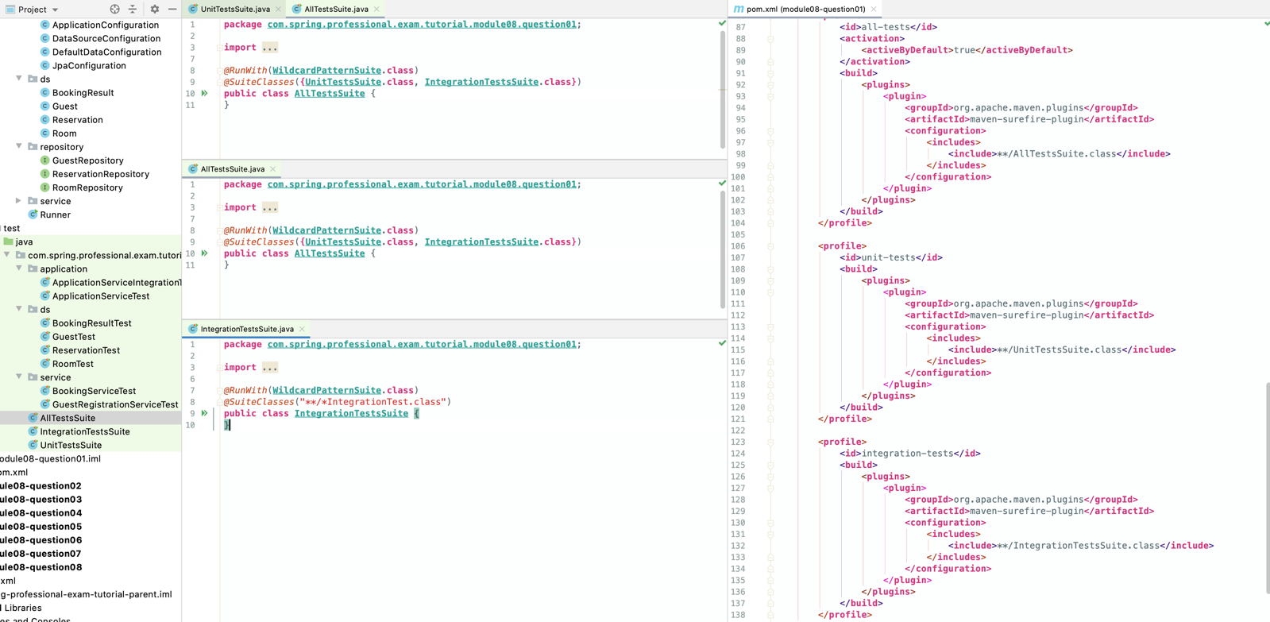

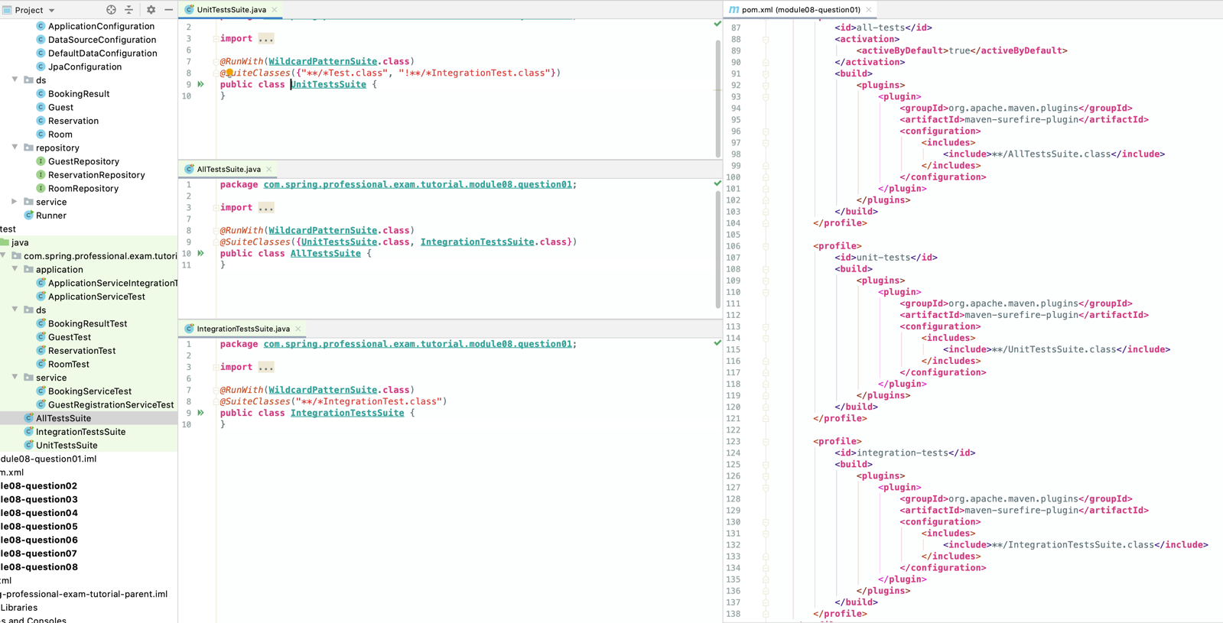

*@RunWith*(**MockitoJUnitRunner**.**class**)  
**public class ApplicationServiceTest** {  
  
 **private static final String *JOHN*** = "John";  
 **private static final String *DOE*** = "Doe";  
 **private static final Guest *GUEST_TO_REGISTER*** = **new** Guest(***JOHN***, ***DOE***);  
 **private static final LocalDate *DATE_2020_JULY_20*** = **LocalDate**.*of*(2020, 7, 20);  
  
 *@InjectMocks* **private ApplicationService** applicationService;  
 *@Mock* **private GuestRegistrationService** guestRegistrationService;  
 *@Mock* **private BookingService** bookingService;  
  
 *@Mock* **private Room** room;  
 *@Mock* **private Guest** registeredGuest;  
 *@Mock* **private Reservation** reservation;  
  
 *@Test* **public void** shouldBookRoomAfterRegisteringUserAndConfirmingRoomAvailability() *{* mockAvailableRoomAtDate(***DATE_2020_JULY_20***, room);  
 mockGuestRegistration(***GUEST_TO_REGISTER***, registeredGuest);  
 mockRoomBookingProcess(room, registeredGuest, ***DATE_2020_JULY_20***);  
  
 **BookingResult** bookingResult = applicationService.bookAnyRoomForNewGuest(***JOHN***, ***DOE***, ***DATE_2020_JULY_20***);  
  
 verifyGuestRegistrationPerformed(***GUEST_TO_REGISTER***);  
 verifyRoomBookingProcessPerformed(room, registeredGuest, ***DATE_2020_JULY_20***);  
  
 *assertEquals*(***ROOM_BOOKED***, bookingResult.getBookingState());  
 *assertEquals*(**Optional**.*of(*reservation*)*, bookingResult.getReservation());  
 *}  
  
 @Test* **public void** shouldRejectBookingRequestWhenNoRoomAvailable() *{* mockNoRoomAvailableAtDate(***DATE_2020_JULY_20***);  
  
 **BookingResult** bookingResult = applicationService.bookAnyRoomForNewGuest(***JOHN***, ***DOE***, ***DATE_2020_JULY_20***);  
  
 verifyGuestRegistrationWasNotPerformed();  
 verifyRoomBookingProcessWasNotPerformed();  
  
 *assertEquals*(***NO_ROOM_AVAILABLE***, bookingResult.getBookingState());  
 *assertEquals*(**Optional**.*empty*(), bookingResult.getReservation());  
 *}  
  
 @Test* **public void** shouldRegisterGuest() *{* **Guest** guestToRegister = **new** Guest(***JOHN***, ***DOE***);  
 mockGuestRegistration(guestToRegister, registeredGuest);  
  
 **Guest** newlyRegisteredGuest = applicationService.registerGuest(***JOHN***, ***DOE***);  
  
 verifyGuestRegistrationPerformed(guestToRegister);  
  
 *assertSame*(registeredGuest, newlyRegisteredGuest);  
 *}  
  
 @Test* **public void** shouldBookAnyRoomForRegisteredUser() *{* mockAvailableRoomAtDate(***DATE_2020_JULY_20***, room);  
 mockRoomBookingProcess(room, registeredGuest, ***DATE_2020_JULY_20***);  
  
 **BookingResult** bookingResult = applicationService.bookAnyRoomForRegisteredGuest(registeredGuest, ***DATE_2020_JULY_20***);  
  
 verifyRoomBookingProcessPerformed(room, registeredGuest, ***DATE_2020_JULY_20***);  
  
 *assertEquals*(***ROOM_BOOKED***, bookingResult.getBookingState());  
 *assertEquals*(**Optional**.*of(*reservation*)*, bookingResult.getReservation());  
 *}  
  
 @Test* **public void** shouldRejectBookingRequestForRegisteredUserWhenNoRoomAvailable() *{* mockNoRoomAvailableAtDate(***DATE_2020_JULY_20***);  
  
 **BookingResult** bookingResult = applicationService.bookAnyRoomForRegisteredGuest(registeredGuest, ***DATE_2020_JULY_20***);  
  
 verifyRoomBookingProcessWasNotPerformed();  
  
 *assertEquals*(***NO_ROOM_AVAILABLE***, bookingResult.getBookingState());  
 *assertEquals*(**Optional**.*empty*(), bookingResult.getReservation());  
 *}  
  
 @Test* **public void** shouldBookSpecificRoomForRegisteredGuest() *{* mockSpecificRoomAvailableAtDate(***YELLOW_ROOM***, registeredGuest, ***DATE_2020_JULY_20***);  
  
 **BookingResult** bookingResult = applicationService.bookSpecificRoomForRegisteredGuest(registeredGuest, ***YELLOW_ROOM***, ***DATE_2020_JULY_20***);  
  
 *assertEquals*(***ROOM_BOOKED***, bookingResult.getBookingState());  
 *assertEquals*(**Optional**.*of(*reservation*)*, bookingResult.getReservation());  
 *}  
  
 @Test* **public void** shouldRejectBookSpecificRoomForRegisteredGuest() *{* mockSpecificRoomNotAvailableAtDate(***YELLOW_ROOM***, registeredGuest, ***DATE_2020_JULY_20***);  
  
 **BookingResult** bookingResult = applicationService.bookSpecificRoomForRegisteredGuest(registeredGuest, ***YELLOW_ROOM***, ***DATE_2020_JULY_20***);  
  
 *assertEquals*(***NO_ROOM_AVAILABLE***, bookingResult.getBookingState());  
 *assertEquals*(**Optional**.*empty*(), bookingResult.getReservation());  
 *}* **private void** mockAvailableRoomAtDate(**LocalDate** date, **Room** availableRoom) *{  
 when*(bookingService.findAvailableRoom*(*date*)*).thenReturn(**Optional**.*of(*availableRoom*)*);  
 *}* **private void** mockNoRoomAvailableAtDate(**LocalDate** date) *{  
 when*(bookingService.findAvailableRoom*(*date*)*).thenReturn(**Optional**.*empty*());  
 *}* **private void** mockSpecificRoomAvailableAtDate(**String** roomName, **Guest** guest, **LocalDate** date) *{  
 when*(bookingService.bookRoom*(*roomName, guest, date*)*).thenReturn(**Optional**.*of(*reservation*)*);  
 *}* **private void** mockSpecificRoomNotAvailableAtDate(**String** roomName, **Guest** guest, **LocalDate** date) *{  
 when*(bookingService.bookRoom*(*roomName, guest, date*)*).thenReturn(**Optional**.*empty*());  
 *}* **private void** mockGuestRegistration(**Guest** guestToRegister, **Guest** registeredGuest) *{  
 when*(guestRegistrationService.registerGuest*(*guestToRegister*)*).thenReturn(registeredGuest);  
 *}* **private void** mockRoomBookingProcess(**Room** room, **Guest** registeredGuest, **LocalDate** bookingAtDate) *{  
 when*(bookingService.bookRoom*(*room, registeredGuest, bookingAtDate*)*).thenReturn(**Optional**.*of(*reservation*)*);  
 *}* **private void** verifyGuestRegistrationPerformed(**Guest** guestToRegister) *{  
 verify*(guestRegistrationService).registerGuest(guestToRegister);  
 *}* **private void** verifyGuestRegistrationWasNotPerformed() *{  
 verify*(guestRegistrationService, *never*()).registerGuest(*any*());  
 *}* **private void** verifyRoomBookingProcessPerformed(**Room** room, **Guest** registeredGuest, **LocalDate** bookingAtDate) *{  
 verify*(bookingService).bookRoom(room, registeredGuest, bookingAtDate);  
 *}* **private void** verifyRoomBookingProcessWasNotPerformed() *{  
 verify*(bookingService, *never*()).bookRoom(*any(***Room**.**class***)*, *any*(), *any*());  
 *}*}

*@RunWith*(**SpringRunner**.**class**)  
*@ContextConfiguration*(classes = **ApplicationConfiguration**.**class**)  
**public class ApplicationServiceIntegrationTest** {  
  
 **private static final String *JOHN*** = "John";  
 **private static final String *DOE*** = "Doe";  
 **private static final LocalDate *DATE_2020_JULY_20*** = **LocalDate**.*of*(2020, 7, 20);  
  
 *@Autowired* **private ApplicationService** applicationService;  
 *@Autowired* **private** RoomRepository roomRepository;  
 *@Autowired* **private** ReservationRepository reservationRepository;  
  
 *@Test  
 @DirtiesContext* **public void** shouldBookAnyRoomForNewGuest() *{* **BookingResult** bookingResult = applicationService.bookAnyRoomForNewGuest(***JOHN***, ***DOE***, ***DATE_2020_JULY_20***);  
  
 assertReservationAcceptedAndSaved(bookingResult, ***DATE_2020_JULY_20***);  
 assertGuestRegisteredCorrectly(bookingResult, ***JOHN***, ***DOE***);  
 *}  
  
 @Test  
 @DirtiesContext* **public void** shouldRegisterGuest() *{* **Guest** registerGuest = applicationService.registerGuest(***JOHN***, ***DOE***);  
  
 assertGuestRegisteredCorrectly(registerGuest, ***JOHN***, ***DOE***);  
 *}  
  
 @Test  
 @DirtiesContext* **public void** shouldBookAnyRoomForRegisteredGuest() *{* **Guest** registerGuest = applicationService.registerGuest(***JOHN***, ***DOE***);  
 **BookingResult** bookingResult = applicationService.bookAnyRoomForRegisteredGuest(registerGuest, ***DATE_2020_JULY_20***);  
  
 assertReservationAcceptedAndSaved(bookingResult, ***DATE_2020_JULY_20***);  
 *}  
  
 @Test  
 @DirtiesContext* **public void** shouldRejectReservationWhenNoRoomsAvailable() *{* roomRepository.deleteAll();  
  
 **BookingResult** bookingResult = applicationService.bookAnyRoomForNewGuest(***JOHN***, ***DOE***, ***DATE_2020_JULY_20***);  
  
 assertReservationRejected(bookingResult);  
 *}  
  
 @Test  
 @DirtiesContext* **public void** shouldRejectReservationWhenAllRoomsBooked() *{* **Guest** registerGuest = applicationService.registerGuest(***JOHN***, ***DOE***);  
  
 **BookingResult** bookingResult1 = applicationService.bookSpecificRoomForRegisteredGuest(registerGuest, ***GREEN_ROOM***, ***DATE_2020_JULY_20***);  
 **BookingResult** bookingResult2 = applicationService.bookSpecificRoomForRegisteredGuest(registerGuest, ***YELLOW_ROOM***, ***DATE_2020_JULY_20***);  
 **BookingResult** bookingResult3 = applicationService.bookSpecificRoomForRegisteredGuest(registerGuest, ***BLUE_ROOM***, ***DATE_2020_JULY_20***);  
  
 **BookingResult** bookingResult = applicationService.bookAnyRoomForRegisteredGuest(registerGuest, ***DATE_2020_JULY_20***);  
  
 assertReservationRejected(bookingResult);  
  
 assertReservationForSpecificRoom(bookingResult1, ***GREEN_ROOM***);  
 assertReservationForSpecificRoom(bookingResult2, ***YELLOW_ROOM***);  
 assertReservationForSpecificRoom(bookingResult3, ***BLUE_ROOM***);  
  
 assertReservationAcceptedAndSaved(bookingResult1, ***DATE_2020_JULY_20***);  
 assertReservationAcceptedAndSaved(bookingResult2, ***DATE_2020_JULY_20***);  
 assertReservationAcceptedAndSaved(bookingResult3, ***DATE_2020_JULY_20***);  
 *}  
  
 @Test  
 @DirtiesContext* **public void** shouldBookSpecificRoom() *{* **Guest** registerGuest = applicationService.registerGuest(***JOHN***, ***DOE***);  
 **BookingResult** bookingResult = applicationService.bookSpecificRoomForRegisteredGuest(registerGuest, ***YELLOW_ROOM***, ***DATE_2020_JULY_20***);  
  
 assertReservationAccepted(bookingResult);  
 assertReservationForSpecificRoom(bookingResult, ***YELLOW_ROOM***);  
 assetReservationAtDate(bookingResult, ***DATE_2020_JULY_20***);  
 assertReservationSaved(bookingResult, getReservationFromRepository*(*bookingResult*)*);  
 *}* **private void** assertReservationAcceptedAndSaved(**BookingResult** bookingResult, **LocalDate** date) *{* assertReservationAccepted(bookingResult);  
 assetReservationAtDate(bookingResult, date);  
 assertRoomReservedFromAvailableRooms(bookingResult, roomRepository.findAll());  
 assertReservationSaved(bookingResult, getReservationFromRepository*(*bookingResult*)*);  
 *}* **private void** assertReservationAccepted(**BookingResult** bookingResult) *{  
 assertEquals*(***ROOM_BOOKED***, bookingResult.getBookingState());  
 *assertTrue*(bookingResult.getReservation().isPresent());  
 *assertNotNull*(bookingResult.getReservation().get().getId());  
 *}* **private void** assertReservationRejected(**BookingResult** bookingResult) *{  
 assertEquals*(***NO_ROOM_AVAILABLE***, bookingResult.getBookingState());  
 *assertFalse*(bookingResult.getReservation().isPresent());  
 *}* **private void** assetReservationAtDate(**BookingResult** bookingResult, **LocalDate** expectedReservationDate) *{* **LocalDate** reservationDate = bookingResult.getReservation().orElseThrow().getReservationDate();  
  
 *assertEquals*(expectedReservationDate, reservationDate);  
 *}* **private void** assertGuestRegisteredCorrectly(**BookingResult** bookingResult, **String** firstName, **String** lastName) *{* **Guest** guest = bookingResult.getReservation().orElseThrow().getGuest();  
  
 assertGuestRegisteredCorrectly(guest, firstName, lastName);  
 *}* **private void** assertGuestRegisteredCorrectly(**Guest** guest, **String** firstName, **String** lastName) *{  
 assertNotNull*(guest.getId());  
 *assertEquals*(firstName, guest.getFirstName());  
 *assertEquals*(lastName, guest.getLastName());  
 *}* **private void** assertRoomReservedFromAvailableRooms(**BookingResult** bookingResult, Set<**Room**> availableRooms) *{* **Room** reservedRoom = bookingResult.getReservation().orElseThrow().getRoom();  
  
 *assertThat*(availableRooms)  
 .contains(reservedRoom);  
 *}* **private Reservation** getReservationFromRepository(**BookingResult** bookingResult) *{* **return** reservationRepository.findById(bookingResult.getReservation().orElseThrow().getId()).orElseThrow();  
 *}* **private void** assertReservationSaved(**BookingResult** bookingResult, **Reservation** savedReservation) *{  
 assertEquals*(bookingResult.getReservation().orElseThrow(), savedReservation);  
 *}* **private void** assertReservationForSpecificRoom(**BookingResult** bookingResult, **String** roomName) *{  
 assertEquals*(roomName, bookingResult.getReservation().orElseThrow().getRoom().getName());  
 *}*}

# Question 02-What type of tests typically use Spring?

Integration Tests are type of tests that typically use Spring Reason for it is that on Integrate Test level we want to test multiple components that are combined together and we want to check if those components provide requested functionalities when cooperating together under environment that should be close to production one, however with assumptions that some of components might still be mocked When performing Integration Test we want to initiate subset of system and execute test against it IoC /DI Container is used for this kind of testing, with some simplification upon deployment or container execution Dependencies are resolved and injected by Spring

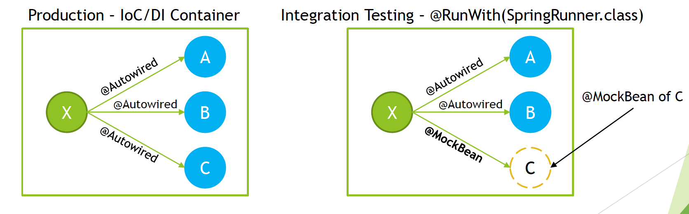

Spring provides great support for integration testing, with main goals of the support being

* Management of Spring IoC container and IoC container caching between tests
  + Spring will create and manage IoC container for tests
  + Context can be reused between tests
  + Main purpose of context being reused is to improve tests execution time
  + Execution times of integration tests might be long mainly because of Embedded Database, Hibernate and other components that are created once context is created
* Dependency Injection in tests
  + Allows for easy Spring Test definition with usage of @RunWith(SpringRunner class)
  + @ContextConfiguration can be used in tests to configure context
  + Support for @Autowired, @Inject
  + Allows customization with @TestExecutionListener
* Transaction management appropriate to integration testing
  + Resolves issue with test affecting each other on data level by implementing proper transaction management
  + By default, all transactions are roll back transactions
  + Gives ability to commit transactions if required

Additionally Spring provides following tools to simplify Integration Testing

* JDBC Testing Support
  + JdbcTestUtils provides JDBC related utility functions
  + countRowsInTable , countRowsInTableWhere , deleteFromTables , deleteFromTableWhere ,
* Spring MVC Testing Support
  + Allow for easy setup with
    - @RunWith(SpringRunner class)
    - @WebAppConfiguration
    - @ContextConfiguration
  + Automatically creates MockMvc
* HtmlUnit Integration
  + Simplifies end to end testing for HTML views
* Client Side REST Tests
  + Allows you to test Client code that interacts with mocked REST Service
  + Use RestTemplate with MockRestServiceServer to make assertions on mock

## Spring annotations for Integration Testing

* @ContextConfiguration
  + Allows you to specify how to load and configure an ApplicationContext for integration tests
  + You can specify @Configuration classes that will be used during ApplicationContext loading
  + Optionally, you can specify XML configuration files locations, if you are using it instead of annotated @Configuration classes
  + *@RunWith*(**SpringRunner**.**class**)  
    *@ContextConfiguration*(classes = **ApplicationConfiguration**.**class**)  
    **public class ApplicationServiceIntegrationTest** {
* @BootstrapWith
  + Allows for low level control on how Context for Tests is created
  + To implement custom bootstrapped, it is best to extend AbstractTestContextBootstrapper
  + Used at class level
* @DirtiesContext
  + Marks test as one that modifies state of context, and it means that context should be recreated prior next test execution because otherwise modified context state might affect test execution
  + *@Test  
    @DirtiesContext***public void** shouldFetchGuestSharableData() *{  
     when*(guestSharableDataServiceMock.getGuestSharableData()).thenReturn(***SHARABLE_DATA***);  
      
     **String** guestSharableData = applicationService.getGuestSharableData();  
      
     *assertEquals*(***SHARABLE_DATA***, guestSharableData);  
    *}*
  + When used at class-level you can specify following modes:
    - BEFORE_CLASS
    - BEFORE_EACH_TEST_METHOD
    - AFTER_EACH_TEST_METHOD
    - AFTER_CLASS
    - @DirtiesContext(classMode = *AFTER_EACH_TEST_METHOD*)
  + When used at method-level you can specify following modes:
    - BEFORE_METHOD
    - AFTER_METHOD
    - @DirtiesContext(methodMode = *AFTER_METHOD*)
* @ActiveProfiles
  + class level annotation that is used to declare which bean definition profiles should be active when loading an ApplicationContext
  + 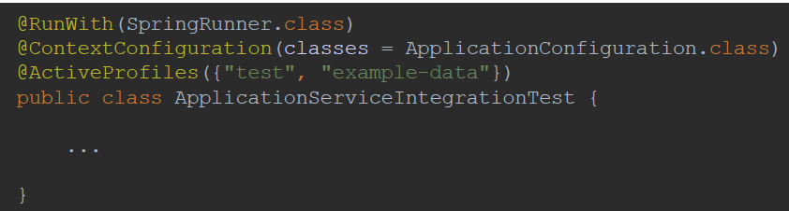
* @TestPropertySource
  + class level annotation that you can use to configure the locations of properties files and inlined properties
  + 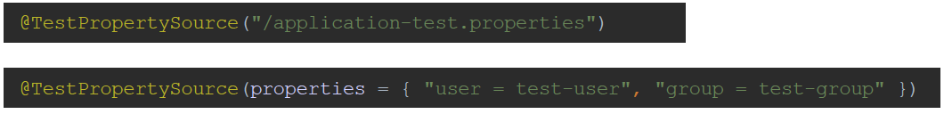
* @WebAppConfiguration
  + class level annotation that triggers creation of MockServletContext , which serves as the ServletContext for the test’s WebApplicationContext
  + Indicates that ApplicationContext loaded for an integration test should be a WebApplicationContext
  + 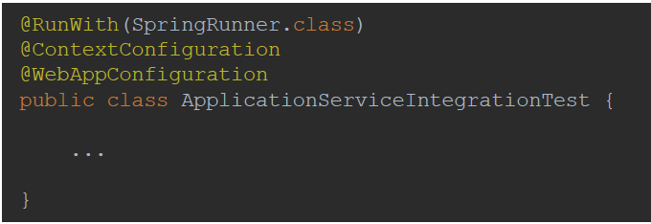
* @ContextHierarchy
  + Used when hierarchy of application contexts has to be used for integration test
  + 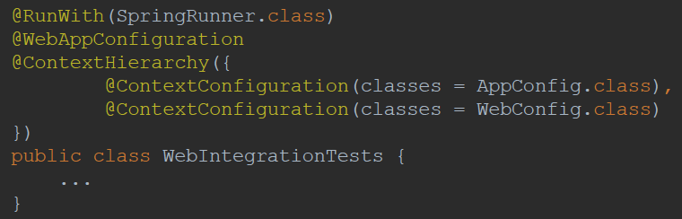
* @TestExecutionListeners
  + Allows registration of TestExecutionListener which allows for customization of test execution
  + Example of TestExecutionListener that is registered by default is DirtiesContextTestExecutionListener
  + 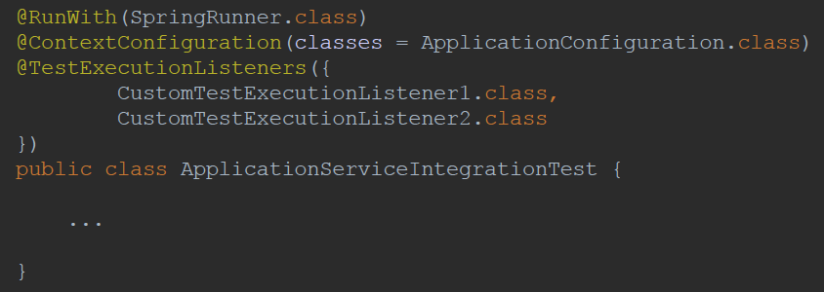
* @Commit
  + class or method level annotation
  + indicates that after test execution, transaction should be committed
  + 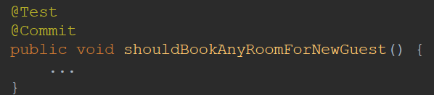
* @Rollback
  + class or method level annotation that indicates that transaction should be rolled back after test execution
  + Even if @Rollback is not explicitly defined, all transactions under tests will be rolled backed by default
  + 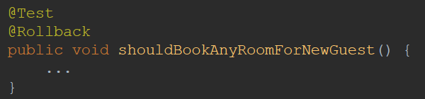
* @BeforeTransaction
  + Indicates method that should be executed before transaction is started
* @AfterTransaction
  + Indicates method that should be executed after transaction is started
* @Sql
  + Indicates SQL scripts that should be executed against database during integration test
  + 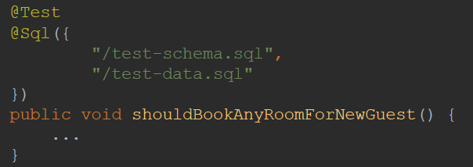
* @SqlConfig
  + Defines metadata used for SQL script parsing
  + 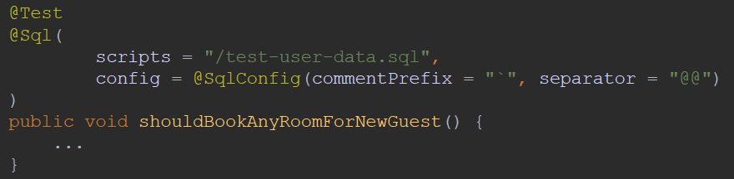
* @SqlGroup
  + Allows you to use multiple @Sql annotations
  + 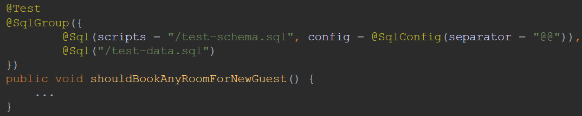

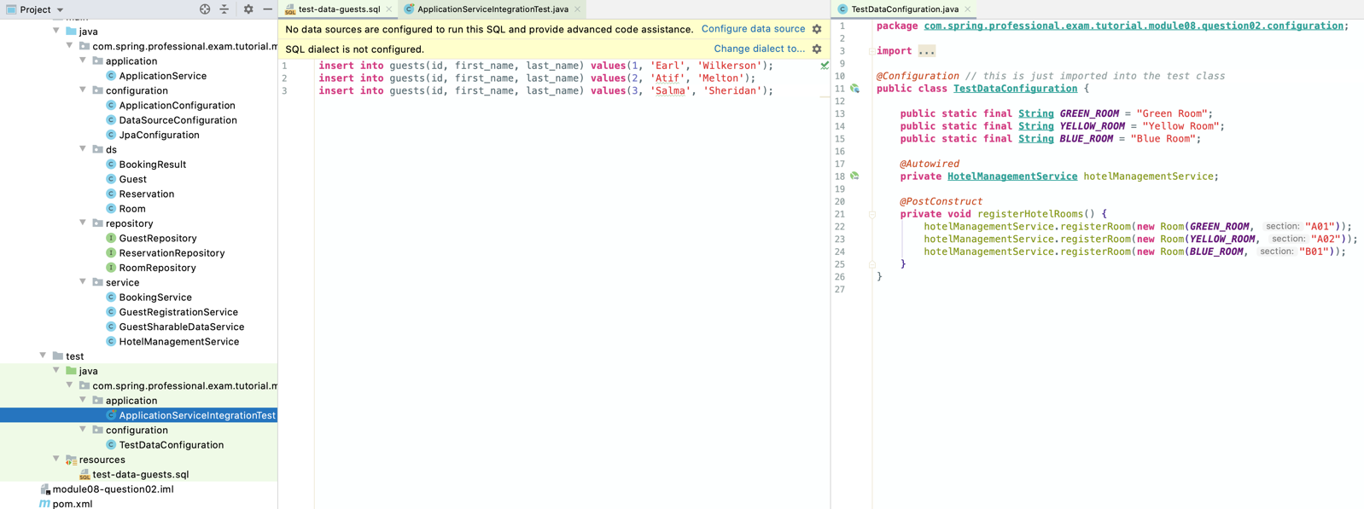

*@RunWith*(**SpringRunner**.**class**)  
*@ContextConfiguration*(classes = **ApplicationConfiguration**.**class**)  
**public class ApplicationServiceIntegrationTest** {  
  
 **private static final String *JOHN*** = "John";  
 **private static final String *DOE*** = "Doe";  
 **private static final LocalDate *DATE_2020_JULY_20*** = **LocalDate**.*of*(2020, 7, 20);  
 **private static final String *SHARABLE_DATA*** = "FirstName1 LastName1, FirstName2 LastName2";  
  
 *@Autowired* **private ApplicationService** applicationService;  
  
 *@Autowired* **private** RoomRepository roomRepository;  
 *@Autowired* **private** ReservationRepository reservationRepository;  
  
 *// This mock is created inside ApplicationServiceIntegrationTestMockConfiguration  
 // if you are using Spring Boot, consider usage of @MockBean annotation  
 @Autowired* **private GuestSharableDataService** guestSharableDataServiceMock;  
  
 *@Test* **public void** shouldContainRoomsFromTestConfiguration() *{* Set<**Room**> roomsRegisteredInHotel = applicationService.listRooms();  
  
 *assertThat*(roomsRegisteredInHotel.stream()  
 .map*(***Room**::getName*)* .collect*(***Collectors**.*toSet*()*)*)  
 .containsOnly(***GREEN_ROOM***, ***YELLOW_ROOM***, ***BLUE_ROOM***);  
 *}  
  
 @Sql*("/test-data-guests.sql")  
 *@Test  
 @DirtiesContext* **public void** shouldContainGuestsFromTestDataScript() *{* List<**Guest**> guests = applicationService.listGuests();  
  
 *assertThat*(guests).containsOnly(  
 **new** Guest*(*1, "Earl", "Wilkerson"*)*,  
 **new** Guest*(*2, "Atif", "Melton"*)*,  
 **new** Guest*(*3, "Salma", "Sheridan"*)* );  
 *}  
  
 @Test  
 @DirtiesContext* **public void** shouldFetchGuestSharableData() *{  
 when*(guestSharableDataServiceMock.getGuestSharableData()).thenReturn(***SHARABLE_DATA***);  
  
 **String** guestSharableData = applicationService.getGuestSharableData();  
  
 *assertEquals*(***SHARABLE_DATA***, guestSharableData);  
 *}  
  
 @Test  
 @DirtiesContext* **public void** shouldBookAnyRoomForNewGuest() *{* **BookingResult** bookingResult = applicationService.bookAnyRoomForNewGuest(***JOHN***, ***DOE***, ***DATE_2020_JULY_20***);  
  
 assertReservationAcceptedAndSaved(bookingResult, ***DATE_2020_JULY_20***);  
 assertGuestRegisteredCorrectly(bookingResult, ***JOHN***, ***DOE***);  
 *}  
  
 @Test  
 @DirtiesContext* **public void** shouldRegisterGuest() *{* **Guest** registerGuest = applicationService.registerGuest(***JOHN***, ***DOE***);  
  
 assertGuestRegisteredCorrectly(registerGuest, ***JOHN***, ***DOE***);  
 *}  
  
 @Test  
 @DirtiesContext* **public void** shouldBookAnyRoomForRegisteredGuest() *{* **Guest** registerGuest = applicationService.registerGuest(***JOHN***, ***DOE***);  
 **BookingResult** bookingResult = applicationService.bookAnyRoomForRegisteredGuest(registerGuest, ***DATE_2020_JULY_20***);  
  
 assertReservationAcceptedAndSaved(bookingResult, ***DATE_2020_JULY_20***);  
 *}  
  
 @Test  
 @DirtiesContext* **public void** shouldRejectReservationWhenNoRoomsAvailable() *{* roomRepository.deleteAll();  
  
 **BookingResult** bookingResult = applicationService.bookAnyRoomForNewGuest(***JOHN***, ***DOE***, ***DATE_2020_JULY_20***);  
  
 assertReservationRejected(bookingResult);  
 *}  
  
 @Test  
 @DirtiesContext* **public void** shouldRejectReservationWhenAllRoomsBooked() *{* **Guest** registerGuest = applicationService.registerGuest(***JOHN***, ***DOE***);  
  
 **BookingResult** bookingResult1 = applicationService.bookSpecificRoomForRegisteredGuest(registerGuest, ***GREEN_ROOM***, ***DATE_2020_JULY_20***);  
 **BookingResult** bookingResult2 = applicationService.bookSpecificRoomForRegisteredGuest(registerGuest, ***YELLOW_ROOM***, ***DATE_2020_JULY_20***);  
 **BookingResult** bookingResult3 = applicationService.bookSpecificRoomForRegisteredGuest(registerGuest, ***BLUE_ROOM***, ***DATE_2020_JULY_20***);  
  
 **BookingResult** bookingResult = applicationService.bookAnyRoomForRegisteredGuest(registerGuest, ***DATE_2020_JULY_20***);  
  
 assertReservationRejected(bookingResult);  
  
 assertReservationForSpecificRoom(bookingResult1, ***GREEN_ROOM***);  
 assertReservationForSpecificRoom(bookingResult2, ***YELLOW_ROOM***);  
 assertReservationForSpecificRoom(bookingResult3, ***BLUE_ROOM***);  
  
 assertReservationAcceptedAndSaved(bookingResult1, ***DATE_2020_JULY_20***);  
 assertReservationAcceptedAndSaved(bookingResult2, ***DATE_2020_JULY_20***);  
 assertReservationAcceptedAndSaved(bookingResult3, ***DATE_2020_JULY_20***);  
 *}  
  
 @Test  
 @DirtiesContext* **public void** shouldBookSpecificRoom() *{* **Guest** registerGuest = applicationService.registerGuest(***JOHN***, ***DOE***);  
 **BookingResult** bookingResult = applicationService.bookSpecificRoomForRegisteredGuest(registerGuest, ***YELLOW_ROOM***, ***DATE_2020_JULY_20***);  
  
 assertReservationAccepted(bookingResult);  
 assertReservationForSpecificRoom(bookingResult, ***YELLOW_ROOM***);  
 assetReservationAtDate(bookingResult, ***DATE_2020_JULY_20***);  
 assertReservationSaved(bookingResult, getReservationFromRepository*(*bookingResult*)*);  
 *}* **private void** assertReservationAcceptedAndSaved(**BookingResult** bookingResult, **LocalDate** date) *{* assertReservationAccepted(bookingResult);  
 assetReservationAtDate(bookingResult, date);  
 assertRoomReservedFromAvailableRooms(bookingResult, roomRepository.findAll());  
 assertReservationSaved(bookingResult, getReservationFromRepository*(*bookingResult*)*);  
 *}* **private void** assertReservationAccepted(**BookingResult** bookingResult) *{  
 assertEquals*(***ROOM_BOOKED***, bookingResult.getBookingState());  
 *assertTrue*(bookingResult.getReservation().isPresent());  
 *assertNotNull*(bookingResult.getReservation().get().getId());  
 *}* **private void** assertReservationRejected(**BookingResult** bookingResult) *{  
 assertEquals*(***NO_ROOM_AVAILABLE***, bookingResult.getBookingState());  
 *assertFalse*(bookingResult.getReservation().isPresent());  
 *}* **private void** assetReservationAtDate(**BookingResult** bookingResult, **LocalDate** expectedReservationDate) *{* **LocalDate** reservationDate = bookingResult.getReservation().orElseThrow().getReservationDate();  
  
 *assertEquals*(expectedReservationDate, reservationDate);  
 *}* **private void** assertGuestRegisteredCorrectly(**BookingResult** bookingResult, **String** firstName, **String** lastName) *{* **Guest** guest = bookingResult.getReservation().orElseThrow().getGuest();  
  
 assertGuestRegisteredCorrectly(guest, firstName, lastName);  
 *}* **private void** assertGuestRegisteredCorrectly(**Guest** guest, **String** firstName, **String** lastName) *{  
 assertNotNull*(guest.getId());  
 *assertEquals*(firstName, guest.getFirstName());  
 *assertEquals*(lastName, guest.getLastName());  
 *}* **private void** assertRoomReservedFromAvailableRooms(**BookingResult** bookingResult, Set<**Room**> availableRooms) *{* **Room** reservedRoom = bookingResult.getReservation().orElseThrow().getRoom();  
  
 *assertThat*(availableRooms)  
 .contains(reservedRoom);  
 *}* **private Reservation** getReservationFromRepository(**BookingResult** bookingResult) *{* **return** reservationRepository.findById(bookingResult.getReservation().orElseThrow().getId()).orElseThrow();  
 *}* **private void** assertReservationSaved(**BookingResult** bookingResult, **Reservation** savedReservation) *{  
 assertEquals*(bookingResult.getReservation().orElseThrow(), savedReservation);  
 *}* **private void** assertReservationForSpecificRoom(**BookingResult** bookingResult, **String** roomName) *{  
 assertEquals*(roomName, bookingResult.getReservation().orElseThrow().getRoom().getName());  
 *}  
  
 @Configuration //using this instead of MockBean as @Springboottest isn't used* **public static class ApplicationServiceIntegrationTestMockConfiguration** *{  
  
 @Bean* **public GuestSharableDataService** guestSharableDataService() *{* **return** *mock*(**GuestSharableDataService**.**class**);  
 *}  
 }*}

# Question 03-How can you create a shared application context in a JUnit integration test?

“Shared Application Context” can be considered as:

*  Sharing Context Definition
*  Sharing Context Instance

Context Definition can be shared between tests in following way:

*  Use Base Class for All Tests which will contain @ContextConfiguration and other annotations, like for example @ActiveProfiles etc.
*  Use Custom Annotation that will contain context configuration
*  Use Test Configuration that Inherits Application Configuration
*  Use Base Interface for all Tests that will contain context configuration

Context Instance is shared by default between all tests, as long as requested context matches one that is already cached.

Context will be reused as long as @ContextConfiguration (locations, classes, initializers, ...), @ActiveProfiles, @TestPropertySource attributes are matched. To see full list of attributes that needs to be matched, you can look at MergedContextConfiguration (equals method) class that is used as key to ContextCache. You can use @DirtiesContext annotation to force Spring to create new instance of context for test.

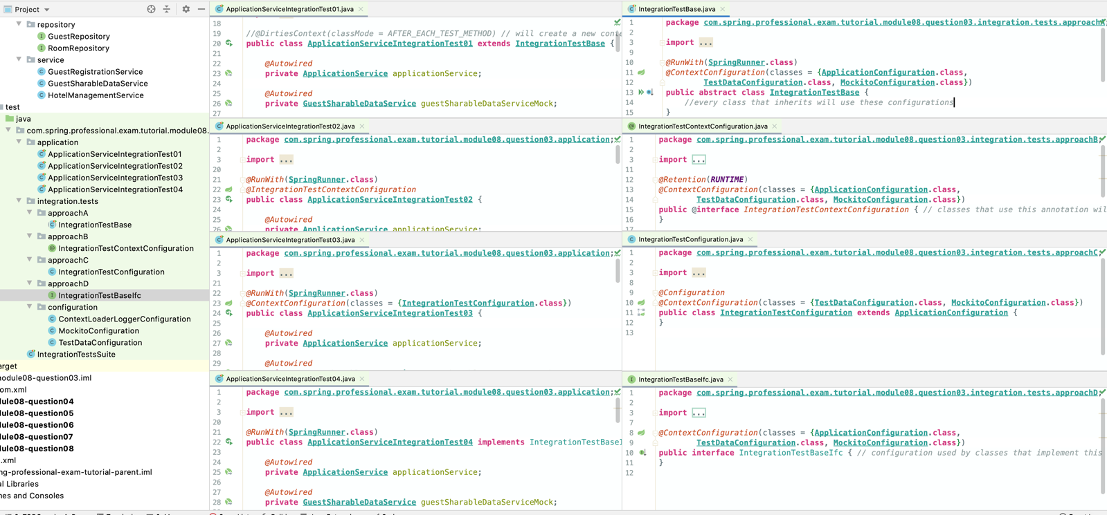

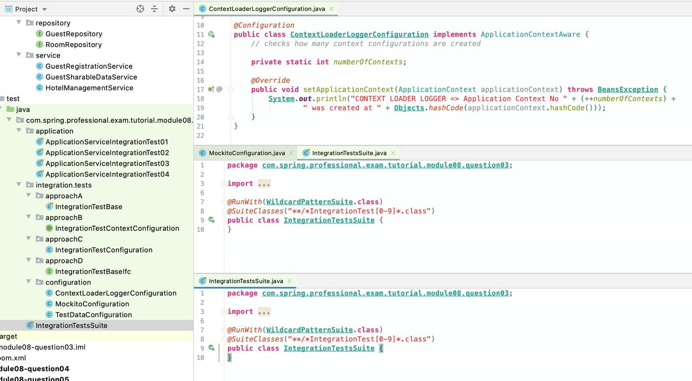

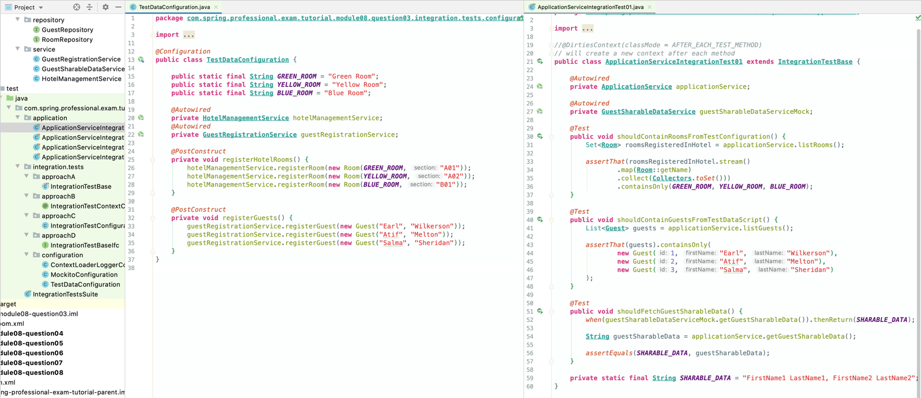

# Question 04-When and where do you use @Transactional in testing?

When you use @Transactional annotation in testing whenever you want to run some part of the code that can alter state of transactional resource, for example database Usage of this annotation allows you to mark code that should execute under transaction and allows to rollback all changes made by test, allowing other tests to pick from clear state

By default, transaction will be rolled back for each test which was executed with @Transactional annotation.

* You can gain additional control over transaction when using @Transactional annotation with
* @Rollback explicitly state to rollback transaction
* @Commit indicates that after test execution, transaction should be committed
* @BeforeTransaction indicates method that should be executed before transaction is started
* @AfterTransaction indicates method that should be executed after transaction is started

Where -@Transactional can be used

* On top of the class each test method in class will be executed in transaction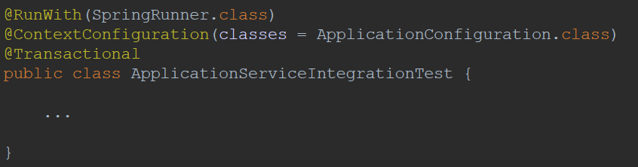
* On top of the method test method will be executed in transaction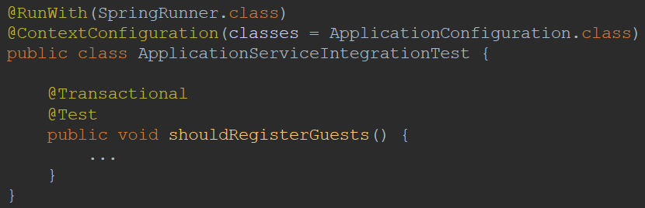

Should use embedded database for integration tests. Difficult to tell if a transaction is committed during a test using an embedded database as it is closed down along with the context.

**drop** database if **exists** `spring-tutorial`;  
**drop** database if **exists** `spring-tutorial`;  
**drop user** if **exists** `spring-tutorial`@'localhost';  
  
**create** database `spring-tutorial`;  
  
**create user** `spring-tutorial`@'localhost' identified **by** 'spring-tutorial';  
**grant all privileges on `spring-tutorial`**.* **TO** `spring-tutorial`@'localhost';  
  
**create table `spring-tutorial`**.**`guests`**(  
 id **int** auto_increment,  
 first_name **varchar***(*32*)*,  
 last_name **varchar***(*32*)*,  
 **primary key** *(*id*)*);  
  
**create table `spring-tutorial`**.**`rooms`**(  
 id **int** auto_increment,  
 **name varchar***(*32*)*,  
 **section varchar***(*32*)*,  
 **primary key** *(*id*)*);

*@RunWith*(**SpringRunner**.**class**)  
*@ContextConfiguration*(classes = **ApplicationConfiguration**.**class**)  
**public class ApplicationServiceIntegrationTest** {  
  
 **private static final Guest *GUEST_1*** = **new** Guest("Michal ", "Leon");  
 **private static final Guest *GUEST_2*** = **new** Guest("Virgie", "Webster");  
 **private static final Guest *GUEST_3*** = **new** Guest("Daphne", "Archer");  
  
 **private static final Room *ROOM_1*** = **new** Room("Green Room", "A01");  
 **private static final Room *ROOM_2*** = **new** Room("Yellow Room", "A02");  
 **private static final Room *ROOM_3*** = **new** Room("Blue Room", "B01");  
  
 *@Autowired* **private ApplicationService** applicationService;  
  
 *@Transactional // removes data from database after test  
 @Test  
 @Commit // will keep data in database* **public void** shouldRegisterGuests() *{* applicationService.registerGuests(***GUEST_1***, ***GUEST_2***, ***GUEST_3***);  
  
 *assertThat*(applicationService.listGuests())  
 .have(elementsWithIdAssigned())  
 .usingElementComparator(guestComparatorWithoutId())  
 .containsExactly(  
 ***GUEST_1***, ***GUEST_2***, ***GUEST_3*** );  
 *}  
  
 @Transactional  
 @Test* **public void** shouldRegisterRooms() *{* applicationService.registerRooms(***ROOM_1***, ***ROOM_2***, ***ROOM_3***);  
  
 *assertThat*(applicationService.listRooms())  
 .have(elementsWithIdAssigned())  
 .usingElementComparator(roomComparatorWithoutId())  
 .containsExactly(  
 ***ROOM_1***, ***ROOM_2***, ***ROOM_3*** );  
 *}  
  
 @BeforeTransaction* **private void** beforeTransaction() *{* **System**.***out***.println("BEFORE TRANSACTION");  
 *}  
  
 @AfterTransaction* **private void** afterTransaction() *{* **System**.***out***.println("AFTER TRANSACTION");  
 *}* **private** Comparator<**Guest**> guestComparatorWithoutId() *{* **return** Comparator  
 .*comparing*(**Guest**::getFirstName)  
 .thenComparing(**Guest**::getLastName);  
 *}* **private** Comparator<**Room**> roomComparatorWithoutId() *{* **return** Comparator  
 .*comparing*(**Room**::getName)  
 .thenComparing(**Room**::getSection);  
 *}* **private Condition**<? **super** Identifiable> elementsWithIdAssigned() *{* **return new Condition**<>() *{  
 @Override* **public boolean** matches(Identifiable identifiable) *{* **return** identifiable.getId() > 0;  
 *}  
 }*;  
 *}*}

# Question 05-How are mock frameworks such as Mockito or EasyMock used?

Mock Frameworks like Mockito or EasyMock are used mainly during Unit Testing to mock collaborators of classes under test Mockito or EasyMock can be also used during Integration Testing when goal is to check cooperation between different objects, while still mocking part of the system.

Mock created with Mockito or EasyMock is a dynamic object, which can “pretend” to be a real object and return predefined results when invoking method on it. Additionally, Mock allows you to verify if expected method were indeed called with expected arguments

Above frameworks also allows you to inject mocks to classes under test in convenient way, with usage of annotations, with style similar to IoC /DI without having to run within container at all, which is one of the reason why unit tests are so fast and lightweight.

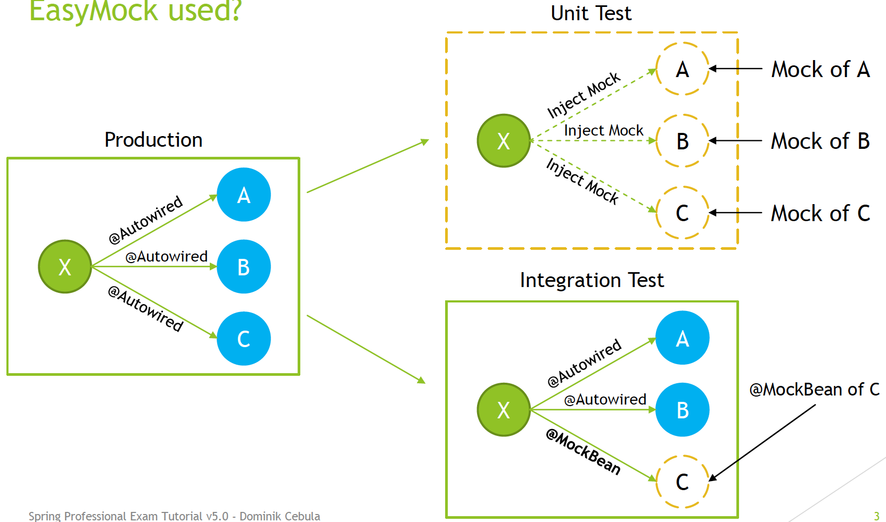

Mockito usage in Unit Test for full documentation go to https :://site mockito org/

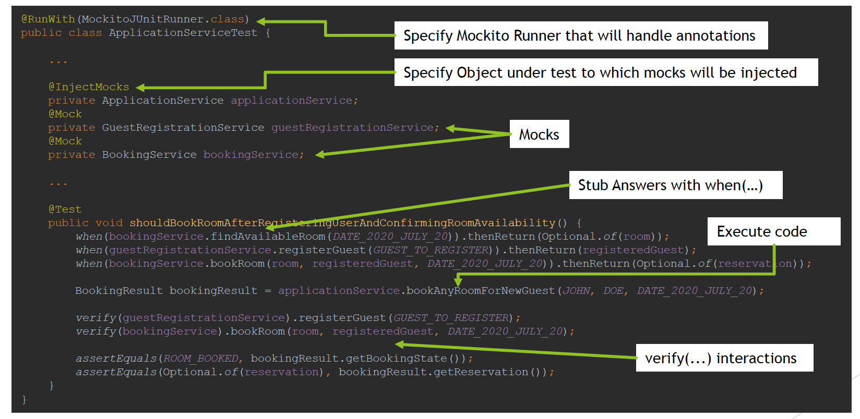

Mockito usage in Integration Test prefer usage of @MockBean is using Spring Boot

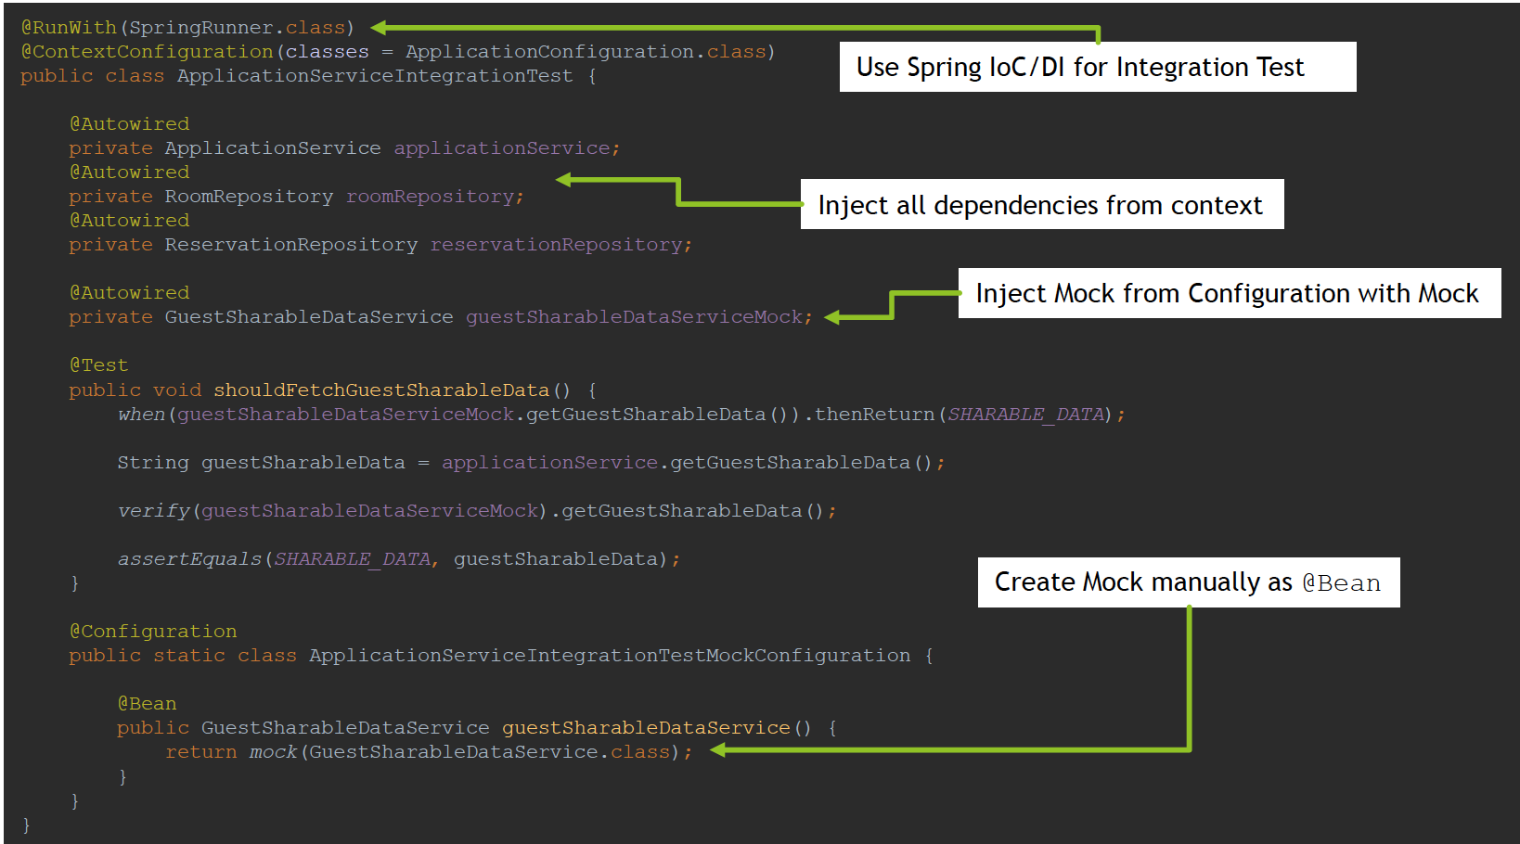

EasyMock usage in Unit Test for full documentation go to https :://easymock org/

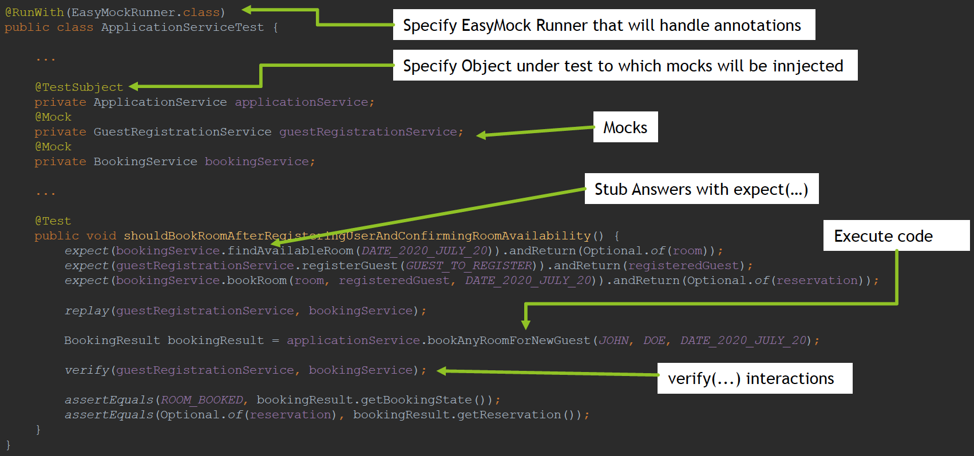

EasyMock usage in Integration Test

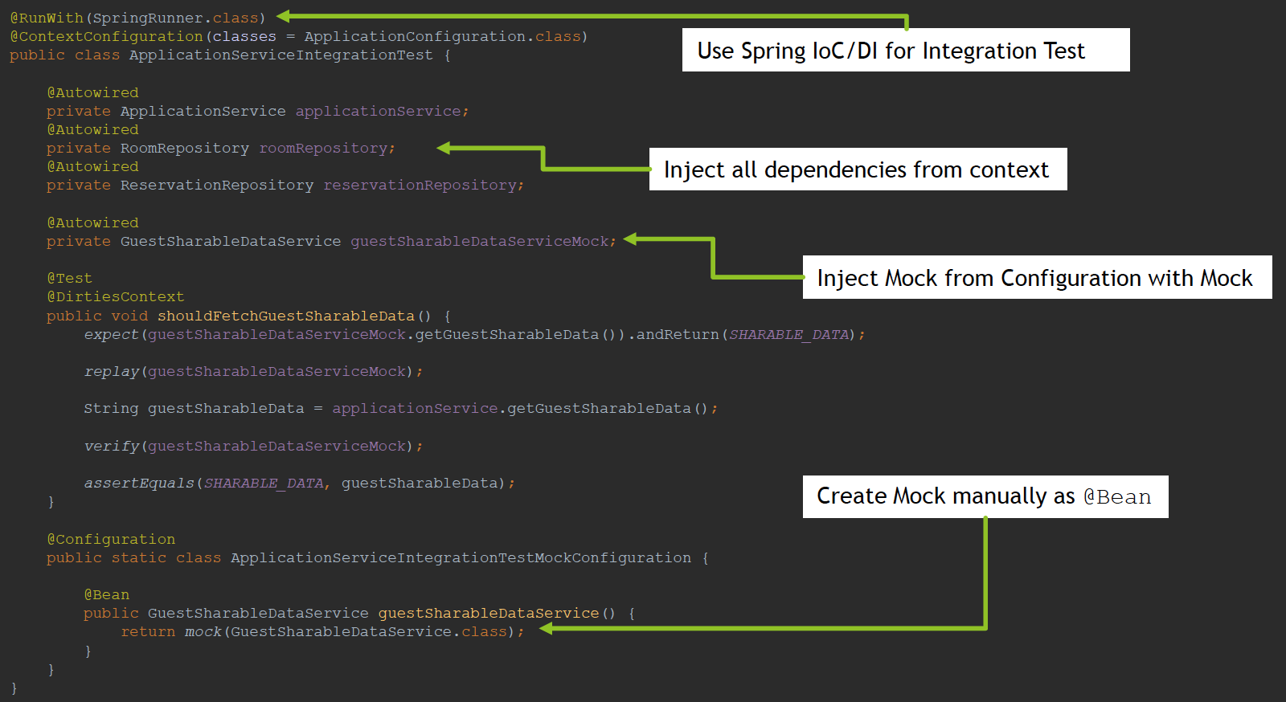

*@RunWith*(**SpringRunner**.**class**)  
*@ContextConfiguration*(classes = **ApplicationConfiguration**.**class**)  
*@ActiveProfiles*("mockito") *// configuration set up below  
// not part of Mockito Framework, this is only to activate right Mock configuration (ApplicationServiceIntegrationTestMockConfiguration)***public class ApplicationServiceIntegrationTest01** {  
  
 **private static final String *JOHN*** = "John";  
 **private static final String *DOE*** = "Doe";  
 **private static final LocalDate *DATE_2020_JULY_20*** = **LocalDate**.*of*(2020, 7, 20);  
 **private static final String *SHARABLE_DATA*** = "FirstName1 LastName1, FirstName2 LastName2";  
  
 *@Autowired* **private ApplicationService** applicationService;  
 *@Autowired* **private** RoomRepository roomRepository;  
 *@Autowired* **private** ReservationRepository reservationRepository;  
  
 *// This mock is created inside ApplicationServiceIntegrationTestMockConfiguration with usage of Mockito  
 // if you are using Spring Boot, consider usage of @MockBean annotation  
 @Autowired* **private GuestSharableDataService** guestSharableDataServiceMock;  
  
 *@Test  
 @DirtiesContext* **public void** shouldFetchGuestSharableData() *{  
 when*(guestSharableDataServiceMock.getGuestSharableData()).thenReturn(***SHARABLE_DATA***);  
  
 **String** guestSharableData = applicationService.getGuestSharableData();  
  
 *assertEquals*(***SHARABLE_DATA***, guestSharableData);  
 *}  
  
 @Test  
 @DirtiesContext* **public void** shouldBookAnyRoomForNewGuest() *{* **BookingResult** bookingResult = applicationService.bookAnyRoomForNewGuest(***JOHN***, ***DOE***, ***DATE_2020_JULY_20***);  
  
 assertReservationAcceptedAndSaved(bookingResult, ***DATE_2020_JULY_20***);  
 assertGuestRegisteredCorrectly(bookingResult, ***JOHN***, ***DOE***);  
 *}  
  
 @Test  
 @DirtiesContext* **public void** shouldRegisterGuest() *{* **Guest** registerGuest = applicationService.registerGuest(***JOHN***, ***DOE***);  
  
 assertGuestRegisteredCorrectly(registerGuest, ***JOHN***, ***DOE***);  
 *}  
  
 @Test  
 @DirtiesContext* **public void** shouldBookAnyRoomForRegisteredGuest() *{* **Guest** registerGuest = applicationService.registerGuest(***JOHN***, ***DOE***);  
 **BookingResult** bookingResult = applicationService.bookAnyRoomForRegisteredGuest(registerGuest, ***DATE_2020_JULY_20***);  
  
 assertReservationAcceptedAndSaved(bookingResult, ***DATE_2020_JULY_20***);  
 *}  
  
 @Test  
 @DirtiesContext* **public void** shouldRejectReservationWhenNoRoomsAvailable() *{* roomRepository.deleteAll();  
  
 **BookingResult** bookingResult = applicationService.bookAnyRoomForNewGuest(***JOHN***, ***DOE***, ***DATE_2020_JULY_20***);  
  
 assertReservationRejected(bookingResult);  
 *}  
  
 @Test  
 @DirtiesContext* **public void** shouldRejectReservationWhenAllRoomsBooked() *{* **Guest** registerGuest = applicationService.registerGuest(***JOHN***, ***DOE***);  
  
 **BookingResult** bookingResult1 = applicationService.bookSpecificRoomForRegisteredGuest(registerGuest, ***GREEN_ROOM***, ***DATE_2020_JULY_20***);  
 **BookingResult** bookingResult2 = applicationService.bookSpecificRoomForRegisteredGuest(registerGuest, ***YELLOW_ROOM***, ***DATE_2020_JULY_20***);  
 **BookingResult** bookingResult3 = applicationService.bookSpecificRoomForRegisteredGuest(registerGuest, ***BLUE_ROOM***, ***DATE_2020_JULY_20***);  
  
 **BookingResult** bookingResult = applicationService.bookAnyRoomForRegisteredGuest(registerGuest, ***DATE_2020_JULY_20***);  
  
 assertReservationRejected(bookingResult);  
  
 assertReservationForSpecificRoom(bookingResult1, ***GREEN_ROOM***);  
 assertReservationForSpecificRoom(bookingResult2, ***YELLOW_ROOM***);  
 assertReservationForSpecificRoom(bookingResult3, ***BLUE_ROOM***);  
  
 assertReservationAcceptedAndSaved(bookingResult1, ***DATE_2020_JULY_20***);  
 assertReservationAcceptedAndSaved(bookingResult2, ***DATE_2020_JULY_20***);  
 assertReservationAcceptedAndSaved(bookingResult3, ***DATE_2020_JULY_20***);  
 *}  
  
 @Test  
 @DirtiesContext* **public void** shouldBookSpecificRoom() *{* **Guest** registerGuest = applicationService.registerGuest(***JOHN***, ***DOE***);  
 **BookingResult** bookingResult = applicationService.bookSpecificRoomForRegisteredGuest(registerGuest, ***YELLOW_ROOM***, ***DATE_2020_JULY_20***);  
  
 assertReservationAccepted(bookingResult);  
 assertReservationForSpecificRoom(bookingResult, ***YELLOW_ROOM***);  
 assetReservationAtDate(bookingResult, ***DATE_2020_JULY_20***);  
 assertReservationSaved(bookingResult, getReservationFromRepository*(*bookingResult*)*);  
 *}* **private void** assertReservationAcceptedAndSaved(**BookingResult** bookingResult, **LocalDate** date) *{* assertReservationAccepted(bookingResult);  
 assetReservationAtDate(bookingResult, date);  
 assertRoomReservedFromAvailableRooms(bookingResult, roomRepository.findAll());  
 assertReservationSaved(bookingResult, getReservationFromRepository*(*bookingResult*)*);  
 *}* **private void** assertReservationAccepted(**BookingResult** bookingResult) *{  
 assertEquals*(***ROOM_BOOKED***, bookingResult.getBookingState());  
 *assertTrue*(bookingResult.getReservation().isPresent());  
 *assertNotNull*(bookingResult.getReservation().get().getId());  
 *}* **private void** assertReservationRejected(**BookingResult** bookingResult) *{  
 assertEquals*(***NO_ROOM_AVAILABLE***, bookingResult.getBookingState());  
 *assertFalse*(bookingResult.getReservation().isPresent());  
 *}* **private void** assetReservationAtDate(**BookingResult** bookingResult, **LocalDate** expectedReservationDate) *{* **LocalDate** reservationDate = bookingResult.getReservation().orElseThrow().getReservationDate();  
  
 *assertEquals*(expectedReservationDate, reservationDate);  
 *}* **private void** assertGuestRegisteredCorrectly(**BookingResult** bookingResult, **String** firstName, **String** lastName) *{* **Guest** guest = bookingResult.getReservation().orElseThrow().getGuest();  
  
 assertGuestRegisteredCorrectly(guest, firstName, lastName);  
 *}* **private void** assertGuestRegisteredCorrectly(**Guest** guest, **String** firstName, **String** lastName) *{  
 assertNotNull*(guest.getId());  
 *assertEquals*(firstName, guest.getFirstName());  
 *assertEquals*(lastName, guest.getLastName());  
 *}* **private void** assertRoomReservedFromAvailableRooms(**BookingResult** bookingResult, Set<**Room**> availableRooms) *{* **Room** reservedRoom = bookingResult.getReservation().orElseThrow().getRoom();  
  
 *assertThat*(availableRooms)  
 .contains(reservedRoom);  
 *}* **private Reservation** getReservationFromRepository(**BookingResult** bookingResult) *{* **return** reservationRepository.findById(bookingResult.getReservation().orElseThrow().getId()).orElseThrow();  
 *}* **private void** assertReservationSaved(**BookingResult** bookingResult, **Reservation** savedReservation) *{  
 assertEquals*(bookingResult.getReservation().orElseThrow(), savedReservation);  
 *}* **private void** assertReservationForSpecificRoom(**BookingResult** bookingResult, **String** roomName) *{  
 assertEquals*(roomName, bookingResult.getReservation().orElseThrow().getRoom().getName());  
 *}  
  
 @Configuration  
 @Profile*("mockito")  
 **public static class ApplicationServiceIntegrationTestMockConfiguration** *{  
  
 @Bean* **public GuestSharableDataService** guestSharableDataService() *{* **return** *mock*(**GuestSharableDataService**.**class**);  
 *}  
 }*}

*@RunWith*(**MockitoJUnitRunner**.**class**)  
**public class ApplicationServiceTest01** {  
  
 **private static final String *JOHN*** = "John";  
 **private static final String *DOE*** = "Doe";  
 **private static final Guest *GUEST_TO_REGISTER*** = **new** Guest(***JOHN***, ***DOE***);  
 **private static final LocalDate *DATE_2020_JULY_20*** = **LocalDate**.*of*(2020, 7, 20);  
  
 *@InjectMocks* **private ApplicationService** applicationService;  
 *@Mock* **private GuestRegistrationService** guestRegistrationService;  
 *@Mock* **private BookingService** bookingService;  
  
 *@Mock* **private Room** room;  
 *@Mock* **private Guest** registeredGuest;  
 *@Mock* **private Reservation** reservation;  
  
 *@Test* **public void** shouldBookRoomAfterRegisteringUserAndConfirmingRoomAvailability() *{* mockAvailableRoomAtDate(***DATE_2020_JULY_20***, room);  
 mockGuestRegistration(***GUEST_TO_REGISTER***, registeredGuest);  
 mockRoomBookingProcess(room, registeredGuest, ***DATE_2020_JULY_20***);  
  
 **BookingResult** bookingResult = applicationService.bookAnyRoomForNewGuest(***JOHN***, ***DOE***, ***DATE_2020_JULY_20***);  
  
 verifyGuestRegistrationPerformed(***GUEST_TO_REGISTER***);  
 verifyRoomBookingProcessPerformed(room, registeredGuest, ***DATE_2020_JULY_20***);  
  
 *assertEquals*(***ROOM_BOOKED***, bookingResult.getBookingState());  
 *assertEquals*(**Optional**.*of(*reservation*)*, bookingResult.getReservation());  
 *}  
  
 @Test* **public void** shouldRejectBookingRequestWhenNoRoomAvailable() *{* mockNoRoomAvailableAtDate(***DATE_2020_JULY_20***);  
  
 **BookingResult** bookingResult = applicationService.bookAnyRoomForNewGuest(***JOHN***, ***DOE***, ***DATE_2020_JULY_20***);  
  
 verifyGuestRegistrationWasNotPerformed();  
 verifyRoomBookingProcessWasNotPerformed();  
  
 *assertEquals*(***NO_ROOM_AVAILABLE***, bookingResult.getBookingState());  
 *assertEquals*(**Optional**.*empty*(), bookingResult.getReservation());  
 *}  
  
 @Test* **public void** shouldRegisterGuest() *{* **Guest** guestToRegister = **new** Guest(***JOHN***, ***DOE***);  
 mockGuestRegistration(guestToRegister, registeredGuest);  
  
 **Guest** newlyRegisteredGuest = applicationService.registerGuest(***JOHN***, ***DOE***);  
  
 verifyGuestRegistrationPerformed(guestToRegister);  
  
 *assertSame*(registeredGuest, newlyRegisteredGuest);  
 *}  
  
 @Test* **public void** shouldBookAnyRoomForRegisteredUser() *{* mockAvailableRoomAtDate(***DATE_2020_JULY_20***, room);  
 mockRoomBookingProcess(room, registeredGuest, ***DATE_2020_JULY_20***);  
  
 **BookingResult** bookingResult = applicationService.bookAnyRoomForRegisteredGuest(registeredGuest, ***DATE_2020_JULY_20***);  
  
 verifyRoomBookingProcessPerformed(room, registeredGuest, ***DATE_2020_JULY_20***);  
  
 *assertEquals*(***ROOM_BOOKED***, bookingResult.getBookingState());  
 *assertEquals*(**Optional**.*of(*reservation*)*, bookingResult.getReservation());  
 *}  
  
 @Test* **public void** shouldRejectBookingRequestForRegisteredUserWhenNoRoomAvailable() *{* mockNoRoomAvailableAtDate(***DATE_2020_JULY_20***);  
  
 **BookingResult** bookingResult = applicationService.bookAnyRoomForRegisteredGuest(registeredGuest, ***DATE_2020_JULY_20***);  
  
 verifyRoomBookingProcessWasNotPerformed();  
  
 *assertEquals*(***NO_ROOM_AVAILABLE***, bookingResult.getBookingState());  
 *assertEquals*(**Optional**.*empty*(), bookingResult.getReservation());  
 *}  
  
 @Test* **public void** shouldBookSpecificRoomForRegisteredGuest() *{* mockSpecificRoomAvailableAtDate(***YELLOW_ROOM***, registeredGuest, ***DATE_2020_JULY_20***);  
  
 **BookingResult** bookingResult = applicationService.bookSpecificRoomForRegisteredGuest(registeredGuest, ***YELLOW_ROOM***, ***DATE_2020_JULY_20***);  
  
 *assertEquals*(***ROOM_BOOKED***, bookingResult.getBookingState());  
 *assertEquals*(**Optional**.*of(*reservation*)*, bookingResult.getReservation());  
 *}  
  
 @Test* **public void** shouldRejectBookSpecificRoomForRegisteredGuest() *{* mockSpecificRoomNotAvailableAtDate(***YELLOW_ROOM***, registeredGuest, ***DATE_2020_JULY_20***);  
  
 **BookingResult** bookingResult = applicationService.bookSpecificRoomForRegisteredGuest(registeredGuest, ***YELLOW_ROOM***, ***DATE_2020_JULY_20***);  
  
 *assertEquals*(***NO_ROOM_AVAILABLE***, bookingResult.getBookingState());  
 *assertEquals*(**Optional**.*empty*(), bookingResult.getReservation());  
 *}* **private void** mockAvailableRoomAtDate(**LocalDate** date, **Room** availableRoom) *{  
 when*(bookingService.findAvailableRoom*(*date*)*).thenReturn(**Optional**.*of(*availableRoom*)*);  
 *}* **private void** mockNoRoomAvailableAtDate(**LocalDate** date) *{  
 when*(bookingService.findAvailableRoom*(*date*)*).thenReturn(**Optional**.*empty*());  
 *}* **private void** mockSpecificRoomAvailableAtDate(**String** roomName, **Guest** guest, **LocalDate** date) *{  
 when*(bookingService.bookRoom*(*roomName, guest, date*)*).thenReturn(**Optional**.*of(*reservation*)*);  
 *}* **private void** mockSpecificRoomNotAvailableAtDate(**String** roomName, **Guest** guest, **LocalDate** date) *{  
 when*(bookingService.bookRoom*(*roomName, guest, date*)*).thenReturn(**Optional**.*empty*());  
 *}* **private void** mockGuestRegistration(**Guest** guestToRegister, **Guest** registeredGuest) *{  
 when*(guestRegistrationService.registerGuest*(*guestToRegister*)*).thenReturn(registeredGuest);  
 *}* **private void** mockRoomBookingProcess(**Room** room, **Guest** registeredGuest, **LocalDate** bookingAtDate) *{  
 when*(bookingService.bookRoom*(*room, registeredGuest, bookingAtDate*)*).thenReturn(**Optional**.*of(*reservation*)*);  
 *}* **private void** verifyGuestRegistrationPerformed(**Guest** guestToRegister) *{  
 verify*(guestRegistrationService).registerGuest(guestToRegister);  
 *}* **private void** verifyGuestRegistrationWasNotPerformed() *{  
 verify*(guestRegistrationService, *never*()).registerGuest(*any*());  
 *}* **private void** verifyRoomBookingProcessPerformed(**Room** room, **Guest** registeredGuest, **LocalDate** bookingAtDate) *{  
 verify*(bookingService).bookRoom(room, registeredGuest, bookingAtDate);  
 *}* **private void** verifyRoomBookingProcessWasNotPerformed() *{  
 verify*(bookingService, *never*()).bookRoom(*any(***Room**.**class***)*, *any*(), *any*());  
 *}*}

*@Configuration***public class TestDataConfiguration** {  
  
 **public static final String *GREEN_ROOM*** = "Green Room";  
 **public static final String *YELLOW_ROOM*** = "Yellow Room";  
 **public static final String *BLUE_ROOM*** = "Blue Room";  
  
 *@Autowired* **private** RoomRepository roomRepository;  
  
 *@PostConstruct* **private void** registerHotelRooms() *{* registerRoom(**new** Room*(****GREEN_ROOM***, "A01"*)*);  
 registerRoom(**new** Room*(****YELLOW_ROOM***, "A02"*)*);  
 registerRoom(**new** Room*(****BLUE_ROOM***, "B01"*)*);  
 *}* **private void** registerRoom(**Room** room) *{* roomRepository.save(room);  
 *}*}

# Question 06-How is @ContextConfiguration used?

@ContextConfiguration annotation is used on top of the class that represents Integration Test, and it’s purpose is to specify how to load and configure Application Context for Integration Test

*@RunWith*(**SpringRunner**.**class**)  
*@ContextConfiguration*(classes = **ApplicationConfiguration**.**class**)  
**public class ApplicationServiceIntegrationTest01** {

@ContextConfiguration annotation can be used in two basic modes:

Annotated Classes Based Approach

XML Based Approach

When @ContextConfiguration annotation is used with Annotated Classes approach, it is expected for classes field to point to class or list of classes that represents @Configuration classes, which will contain information about @ComponentScan or will provide @Bean (s).

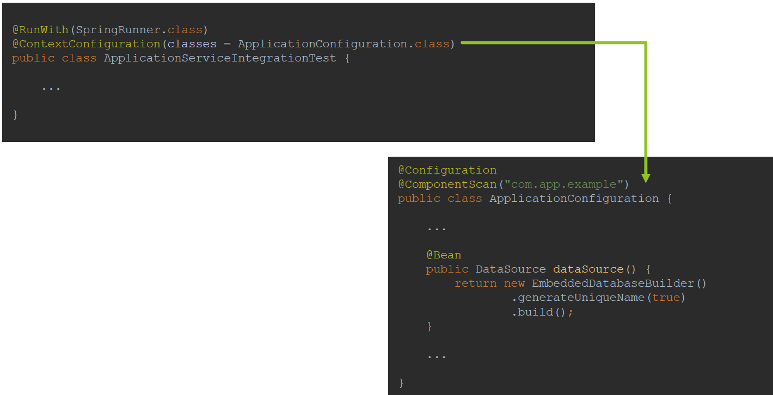

When @ContextConfiguration annotation is used with XML Based Approach, it is expected for locations field to point to context xml definitions or list of context xml definitions

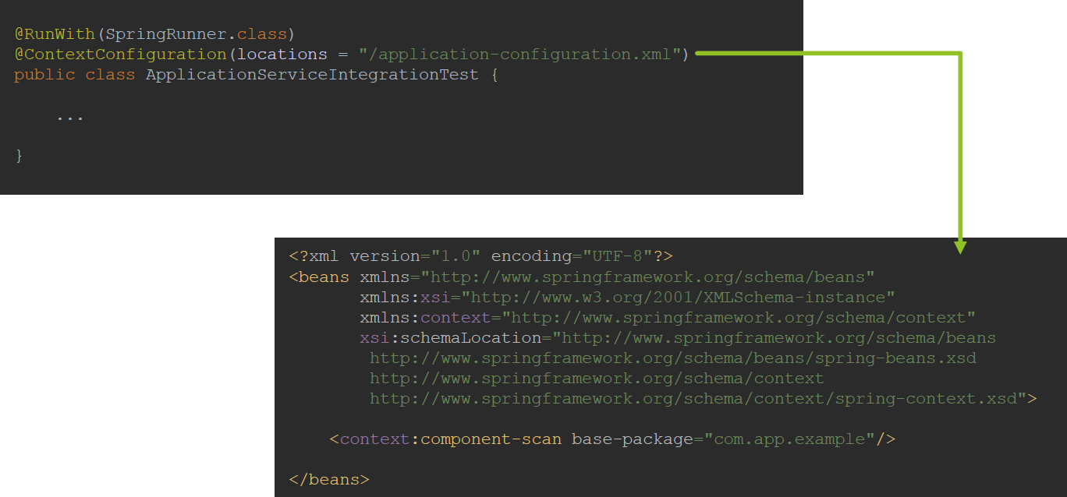

Additionally, @ContextConfiguration annotation also allows you to specify:

* initializers - list of ApplicationContextInitializer used within cases that require some programmatic initialization of the application context
* loader - usually not used and default DelegatingSmartContextLoader is used, if required, this field allows you to specify custom context loader or one of the following:
  + GenericXmlContextLoader
  + GenericGroovyXmlContextLoader
  + AnnotationConfigContextLoader
  + GenericXmlWebContextLoader
  + GenericGroovyXmlWebContextLoader
  + AnnotationConfigWebContextLoader
* name - name of the context hierarchy level represented by this configuration only applicable when used within a test class hierarchy configured using @ContextHierarchy
* inheritLocations - whether or not xml locations or annotated classes from test superclasses should be inherited, default true
* inheritInitializers - whether or not context initializers from test superclasses should be inherited, default true

# Question 07-How does Spring Boot simplify writing tests?

Spring Boot simplifies writing tests in following way:

* Provides @SpringBootTest annotation alternative to @ContextConfiguration , creates ApplicationContext through SpringApplication , Enables Tests Auto Configuration, Enables Spring Boot Test Features
* Provides @MockBean annotation easy creation and injection of Mockito mock
* Provides @SpyBean annotation easy creation and injection of Mockito spy
* Provides @WebMvcTest annotation useful when test focuses only on Spring
* MVC components, disables full auto configuration and applies only configuration relevant to MVC tests
* Provides Web Environments
  + MOCK (default)
  + RANDOM_PORT
  + DEFINED_PORT
  + NONE
* Provides algorithm for Tests Environment Auto Configuration
  + Based on defined dependencies, beans, properties, resources provides beans necessary for integration tests
  + Allows you to focus on test content instead of focusing on how to configure specified technology for integration test
* Allows to explicitly use Auto Configurations:
  + @JsonTest Auto configured JSON Tests
  + @WebMvcTest Auto configured Spring MVC Tests (context limited to MVC)
  + @JdbcTest Auto configured JDBC Tests
  + @DataJpaTest Auto configured Data JPA Tests
  + @JooqTest Auto configured jOOQ Tests
  + @DataMongoTest Auto configured Data MongoDB Tests
  + @RestClientTest Auto configured REST Clients
* Provides spring boot starter test module, which includes:
  + JUnit
  + Spring Test
  + Spring Boot Test
  + AssertJ fluent assertion library.
  + Hamcrest library of matcher objects
  + Mockito mocking framework.
  + JSONassert An assertion library for JSON
  + JsonPath XPath for JSON
* Provides @Conditional annotations
  + @ConditionalOnClass
  + @ConditionalOnMissingBean
  + @ConditionalOnProperty
  + @ConditionalOnResource
  + @ConditionalOnExpression

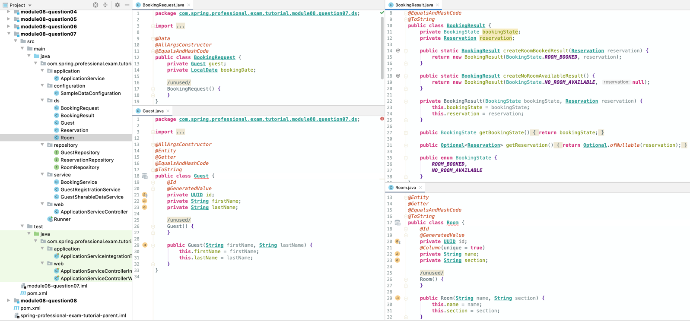

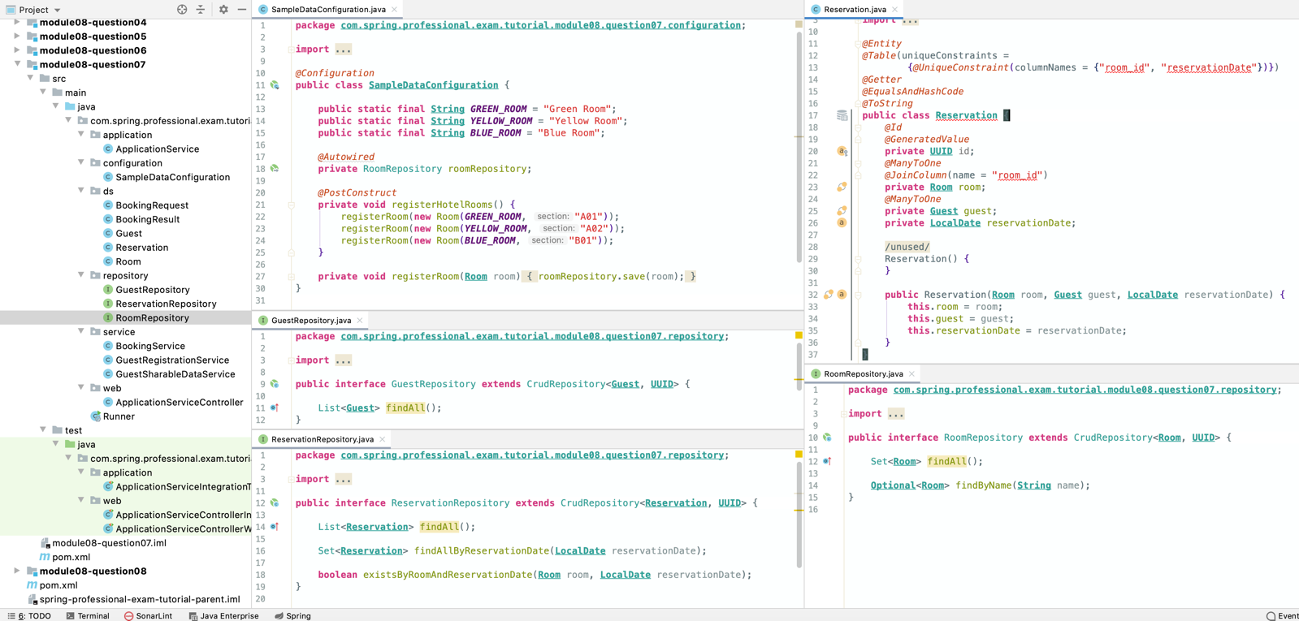

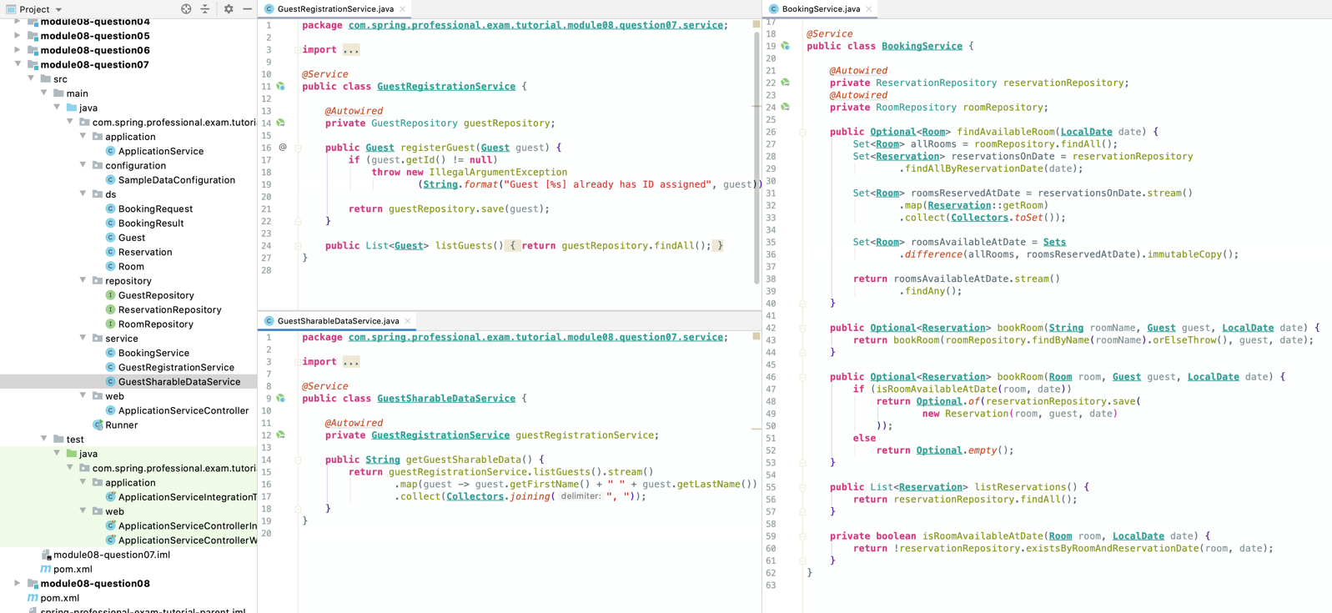

*@RestController  
@RequestMapping*("/api")  
**public class ApplicationServiceController** {  
  
 *@Autowired* **private ApplicationService** applicationService;  
  
 *@PutMapping*("guests")  
 **public Guest** registerGuest(*@RequestBody* **Guest** guest) *{* **return** applicationService.registerGuest(guest);  
 *}  
  
 @GetMapping*("guests")  
 **public** List<**Guest**> listGuests() *{* **return** applicationService.listGuests();  
 *}  
  
 @PutMapping*("bookings")  
 **public void** bookRoom(*@RequestBody* **BookingRequest** bookingRequest) *{* applicationService.bookAnyRoomForRegisteredGuest(bookingRequest.getGuest(), bookingRequest.getBookingDate());  
 *}  
  
 @GetMapping*("bookings")  
 **public** List<**Reservation**> listReservations() *{* **return** applicationService.listReservations();  
 *}*}

*@Service***public class ApplicationService** {  
  
 *@Autowired* **private GuestRegistrationService** guestRegistrationService;  
 *@Autowired* **private BookingService** bookingService;  
 *@Autowired* **private GuestSharableDataService** guestSharableDataService;  
  
 **public BookingResult** bookAnyRoomForNewGuest(**String** firstName, **String** lastName, **LocalDate** date) *{* **Optional**<**Room**> availableRoom = bookingService.findAvailableRoom(date);  
  
 **if** (availableRoom.isPresent()) *{* **Guest** registeredGuest = registerGuest*(*firstName, lastName*)*;  
  
 **return BookingResult**.*createRoomBookedResult(* bookingService.bookRoom*(*availableRoom.get(), registeredGuest, date*)*.orElseThrow()  
 *)*;  
 *}* **else  
 return BookingResult**.*createNoRoomAvailableResult*();  
 *}* **public Guest** registerGuest(**String** firstName, **String** lastName) *{* **return** registerGuest(**new** Guest*(*firstName, lastName*)*);  
 *}* **public Guest** registerGuest(**Guest** guestToRegister) *{* **return** guestRegistrationService.registerGuest(guestToRegister);  
 *}* **public BookingResult** bookAnyRoomForRegisteredGuest(**Guest** guest, **LocalDate** date) *{* **Optional**<**Room**> availableRoom = bookingService.findAvailableRoom(date);  
  
 **if** (availableRoom.isPresent()) *{* **return BookingResult**.*createRoomBookedResult(* bookingService.bookRoom*(*availableRoom.get(), guest, date*)*.orElseThrow()  
 *)*;  
 *}* **else  
 return BookingResult**.*createNoRoomAvailableResult*();  
 *}* **public BookingResult** bookSpecificRoomForRegisteredGuest(**Guest** guest, **String** roomName, **LocalDate** date) *{* **Optional**<**Reservation**> reservation = bookingService.bookRoom(roomName, guest, date);  
  
 **return** reservation  
 .map(**BookingResult**::*createRoomBookedResult*)  
 .orElseGet(**BookingResult**::*createNoRoomAvailableResult*);  
 *}* **public String** getGuestSharableData() *{* **return** guestSharableDataService.getGuestSharableData();  
 *}* **public** List<**Guest**> listGuests() *{* **return** guestRegistrationService.listGuests();  
 *}* **public** List<**Reservation**> listReservations() *{* **return** bookingService.listReservations();  
 *}*}

*@RunWith*(**SpringRunner**.**class**)  
*@SpringBootTest***public class ApplicationServiceIntegrationTest** {  
  
 **private static final String *JOHN*** = "John";  
 **private static final String *DOE*** = "Doe";  
 **private static final LocalDate *DATE_2020_JULY_20*** = **LocalDate**.*of*(2020, 7, 20);  
 **private static final String *SHARABLE_DATA*** = "FirstName1 LastName1, FirstName2 LastName2";  
  
 *@Autowired* **private ApplicationService** applicationService;  
 *@Autowired* **private** RoomRepository roomRepository;  
 *@Autowired* **private** ReservationRepository reservationRepository;  
  
 *@MockBean* **private GuestSharableDataService** guestSharableDataServiceMock;  
  
 *@Test  
 @DirtiesContext* **public void** shouldFetchGuestSharableData() *{  
 when*(guestSharableDataServiceMock.getGuestSharableData()).thenReturn(***SHARABLE_DATA***);  
  
 **String** guestSharableData = applicationService.getGuestSharableData();  
  
 *assertEquals*(***SHARABLE_DATA***, guestSharableData);  
 *}  
  
 @Test  
 @DirtiesContext* **public void** shouldBookAnyRoomForNewGuest() *{* **BookingResult** bookingResult = applicationService.bookAnyRoomForNewGuest(***JOHN***, ***DOE***, ***DATE_2020_JULY_20***);  
  
 assertReservationAcceptedAndSaved(bookingResult, ***DATE_2020_JULY_20***);  
 assertGuestRegisteredCorrectly(bookingResult, ***JOHN***, ***DOE***);  
 *}  
  
 @Test  
 @DirtiesContext* **public void** shouldRegisterGuest() *{* **Guest** registerGuest = applicationService.registerGuest(***JOHN***, ***DOE***);  
  
 assertGuestRegisteredCorrectly(registerGuest, ***JOHN***, ***DOE***);  
 *}  
  
 @Test  
 @DirtiesContext* **public void** shouldBookAnyRoomForRegisteredGuest() *{* **Guest** registerGuest = applicationService.registerGuest(***JOHN***, ***DOE***);  
 **BookingResult** bookingResult = applicationService.bookAnyRoomForRegisteredGuest(registerGuest, ***DATE_2020_JULY_20***);  
  
 assertReservationAcceptedAndSaved(bookingResult, ***DATE_2020_JULY_20***);  
 *}  
  
 @Test  
 @DirtiesContext* **public void** shouldRejectReservationWhenNoRoomsAvailable() *{* roomRepository.deleteAll();  
  
 **BookingResult** bookingResult = applicationService.bookAnyRoomForNewGuest(***JOHN***, ***DOE***, ***DATE_2020_JULY_20***);  
  
 assertReservationRejected(bookingResult);  
 *}  
  
 @Test  
 @DirtiesContext* **public void** shouldRejectReservationWhenAllRoomsBooked() *{* **Guest** registerGuest = applicationService.registerGuest(***JOHN***, ***DOE***);  
  
 **BookingResult** bookingResult1 = applicationService.bookSpecificRoomForRegisteredGuest(registerGuest, **SampleDataConfiguration**.***GREEN_ROOM***, ***DATE_2020_JULY_20***);  
 **BookingResult** bookingResult2 = applicationService.bookSpecificRoomForRegisteredGuest(registerGuest, **SampleDataConfiguration**.***YELLOW_ROOM***, ***DATE_2020_JULY_20***);  
 **BookingResult** bookingResult3 = applicationService.bookSpecificRoomForRegisteredGuest(registerGuest, **SampleDataConfiguration**.***BLUE_ROOM***, ***DATE_2020_JULY_20***);  
  
 **BookingResult** bookingResult = applicationService.bookAnyRoomForRegisteredGuest(registerGuest, ***DATE_2020_JULY_20***);  
  
 assertReservationRejected(bookingResult);  
  
 assertReservationForSpecificRoom(bookingResult1, **SampleDataConfiguration**.***GREEN_ROOM***);  
 assertReservationForSpecificRoom(bookingResult2, **SampleDataConfiguration**.***YELLOW_ROOM***);  
 assertReservationForSpecificRoom(bookingResult3, **SampleDataConfiguration**.***BLUE_ROOM***);  
  
 assertReservationAcceptedAndSaved(bookingResult1, ***DATE_2020_JULY_20***);  
 assertReservationAcceptedAndSaved(bookingResult2, ***DATE_2020_JULY_20***);  
 assertReservationAcceptedAndSaved(bookingResult3, ***DATE_2020_JULY_20***);  
 *}  
  
 @Test  
 @DirtiesContext* **public void** shouldBookSpecificRoom() *{* **Guest** registerGuest = applicationService.registerGuest(***JOHN***, ***DOE***);  
 **BookingResult** bookingResult = applicationService.bookSpecificRoomForRegisteredGuest(registerGuest, **SampleDataConfiguration**.***YELLOW_ROOM***, ***DATE_2020_JULY_20***);  
  
 assertReservationAccepted(bookingResult);  
 assertReservationForSpecificRoom(bookingResult, **SampleDataConfiguration**.***YELLOW_ROOM***);  
 assetReservationAtDate(bookingResult, ***DATE_2020_JULY_20***);  
 assertReservationSaved(bookingResult, getReservationFromRepository*(*bookingResult*)*);  
 *}* **private void** assertReservationAcceptedAndSaved(**BookingResult** bookingResult, **LocalDate** date) *{* assertReservationAccepted(bookingResult);  
 assetReservationAtDate(bookingResult, date);  
 assertRoomReservedFromAvailableRooms(bookingResult, roomRepository.findAll());  
 assertReservationSaved(bookingResult, getReservationFromRepository*(*bookingResult*)*);  
 *}* **private void** assertReservationAccepted(**BookingResult** bookingResult) *{  
 assertEquals*(***ROOM_BOOKED***, bookingResult.getBookingState());  
 *assertTrue*(bookingResult.getReservation().isPresent());  
 *assertNotNull*(bookingResult.getReservation().get().getId());  
 *}* **private void** assertReservationRejected(**BookingResult** bookingResult) *{  
 assertEquals*(***NO_ROOM_AVAILABLE***, bookingResult.getBookingState());  
 *assertFalse*(bookingResult.getReservation().isPresent());  
 *}* **private void** assetReservationAtDate(**BookingResult** bookingResult, **LocalDate** expectedReservationDate) *{* **LocalDate** reservationDate = bookingResult.getReservation().orElseThrow().getReservationDate();  
  
 *assertEquals*(expectedReservationDate, reservationDate);  
 *}* **private void** assertGuestRegisteredCorrectly(**BookingResult** bookingResult, **String** firstName, **String** lastName) *{* **Guest** guest = bookingResult.getReservation().orElseThrow().getGuest();  
  
 assertGuestRegisteredCorrectly(guest, firstName, lastName);  
 *}* **private void** assertGuestRegisteredCorrectly(**Guest** guest, **String** firstName, **String** lastName) *{  
 assertNotNull*(guest.getId());  
 *assertEquals*(firstName, guest.getFirstName());  
 *assertEquals*(lastName, guest.getLastName());  
 *}* **private void** assertRoomReservedFromAvailableRooms(**BookingResult** bookingResult, Set<**Room**> availableRooms) *{* **Room** reservedRoom = bookingResult.getReservation().orElseThrow().getRoom();  
  
 *assertThat*(availableRooms)  
 .contains(reservedRoom);  
 *}* **private Reservation** getReservationFromRepository(**BookingResult** bookingResult) *{* **return** reservationRepository.findById(bookingResult.getReservation().orElseThrow().getId()).orElseThrow();  
 *}* **private void** assertReservationSaved(**BookingResult** bookingResult, **Reservation** savedReservation) *{  
 assertEquals*(bookingResult.getReservation().orElseThrow(), savedReservation);  
 *}* **private void** assertReservationForSpecificRoom(**BookingResult** bookingResult, **String** roomName) *{  
 assertEquals*(roomName, bookingResult.getReservation().orElseThrow().getRoom().getName());  
 *}*}

*@RunWith*(**SpringRunner**.**class**)  
*@SpringBootTest  
@AutoConfigureMockMvc  
@AutoConfigureJsonTesters***public class ApplicationServiceControllerIntegrationTest** {  
  
 **private static final String *API_GUESTS*** = "/api/guests";  
 **private static final String *API_BOOKINGS*** = "/api/bookings";  
  
 **private static final String *GUEST_FIRST_NAME*** = "John";  
 **private static final String *GUEST_LAST_NAME*** = "Doe";  
 **private static final Guest *GUEST*** = **new** Guest(***GUEST_FIRST_NAME***, ***GUEST_LAST_NAME***);  
 **private static final LocalDate *DATE_2020_JULY_20*** = **LocalDate**.*of*(2020, 7, 20);  
  
 *@Autowired* **private MockMvc** mockMvc;  
 *@Autowired* **private JacksonTester**<**Guest**> guestJson;  
 *@Autowired* **private JacksonTester**<List*<***Guest***>*> guestsJson;  
 *@Autowired* **private JacksonTester**<**BookingRequest**> bookingRequestJson;  
 *@Autowired* **private JacksonTester**<List*<***Reservation***>*> reservationsJson;  
  
 *@Test  
 @DirtiesContext* **public void** shouldRegisterGuest() **throws Exception** *{* mockMvc.perform(*put(****API_GUESTS****)*.contentType*(****APPLICATION_JSON****)*.content*(*guestJson.write*(****GUEST****)*.getJson()*)*)  
 .andExpect(*status*().isOk());  
  
 List<**Guest**> guests = guestsJson.parseObject(mockMvc.perform*(get(****API_GUESTS****))* .andExpect*(status*().isOk()*)* .andReturn().getResponse().getContentAsString());  
  
 *assertThat*(guests)  
 .usingElementComparator(guestComparatorWithoutId())  
 .containsOnly(***GUEST***);  
 *}  
  
 @Test  
 @DirtiesContext* **public void** shouldBookRoomForRegisteredGuest() **throws Exception** *{* **Guest** registeredGuest = guestJson.parseObject(mockMvc.perform*(put(****API_GUESTS****)*.contentType*(****APPLICATION_JSON****)*.content*(*guestJson.write*(****GUEST****)*.getJson()*))* .andExpect*(status*().isOk()*)* .andReturn().getResponse().getContentAsString());  
  
 mockMvc.perform(*put(****API_BOOKINGS****)*.contentType*(****APPLICATION_JSON****)*.content*(*bookingRequestJson.write*(***new** BookingRequest*(*registeredGuest, ***DATE_2020_JULY_20****))*.getJson()*)*)  
 .andExpect(*status*().isOk());  
  
 List<**Reservation**> reservations = reservationsJson.parseObject(mockMvc.perform*(get(****API_BOOKINGS****))* .andExpect*(status*().isOk()*)* .andReturn().getResponse().getContentAsString());  
  
 *assertEquals*(1, reservations.size());  
 **Reservation** reservation = reservations.get(0);  
 *assertEquals*(***GUEST_FIRST_NAME***, reservation.getGuest().getFirstName());  
 *assertEquals*(***GUEST_LAST_NAME***, reservation.getGuest().getLastName());  
 *assertEquals*(***DATE_2020_JULY_20***, reservation.getReservationDate());  
 *}* **private** Comparator<**Guest**> guestComparatorWithoutId() *{* **return** Comparator  
 .*comparing*(**Guest**::getFirstName)  
 .thenComparing(**Guest**::getLastName);  
 *}*}

*@RunWith*(**SpringRunner**.**class**)  
*@WebMvcTest*(**ApplicationServiceController**.**class**) lighter test for controller  
*@AutoConfigureJsonTesters***public class ApplicationServiceControllerWebMvcTest** {  
  
 **private static final String *API_GUESTS*** = "/api/guests";  
 **private static final String *API_BOOKINGS*** = "/api/bookings";  
  
 **private static final Guest *GUEST*** = **new** Guest("John", "Doe");  
 **private static final Guest *REGISTERED_GUEST*** = **new** Guest(**UUID**.*randomUUID*(), "John", "Doe");  
 **private static final Guest *SECOND_GUEST*** = **new** Guest("Virgie", "Webster");  
 **private static final Guest *THIRD_GUEST*** = **new** Guest("Daphne", "Archer");  
 **private static final** List<**Guest**> ***GUESTS*** = **Arrays**.*asList*(***GUEST***, ***SECOND_GUEST***, ***THIRD_GUEST***);  
 **private static final LocalDate *DATE_2020_JULY_20*** = **LocalDate**.*of*(2020, 7, 20);  
 **private static final BookingRequest *BOOKING_REQUEST*** = **new** BookingRequest(***GUEST***, ***DATE_2020_JULY_20***);  
 **private static final Reservation *RESERVATION_1*** = **new** Reservation(**new** Room*(*"Room1", "A"*)*, ***GUEST***, ***DATE_2020_JULY_20***);  
 **private static final Reservation *RESERVATION_2*** = **new** Reservation(**new** Room*(*"Room2", "B"*)*, ***SECOND_GUEST***, ***DATE_2020_JULY_20***);  
 **private static final** List<**Reservation**> ***RESERVATIONS*** = **Arrays**.*asList*(***RESERVATION_1***, ***RESERVATION_2***);  
  
 *@Autowired* **private MockMvc** mockMvc;  
  
 *@MockBean* **private ApplicationService** applicationService;  
  
 *@Autowired* **private JacksonTester**<**Guest**> guestJson;  
 *@Autowired* **private JacksonTester**<List*<***Guest***>*> guestsJson;  
 *@Autowired* **private JacksonTester**<**BookingRequest**> bookingRequestJson;  
 *@Autowired* **private JacksonTester**<List*<***Reservation***>*> reservationsJson;  
  
 *@Test* **public void** shouldRegisterGuest() **throws Exception** *{  
 when*(applicationService.registerGuest*(****GUEST****)*).thenReturn(***REGISTERED_GUEST***);  
  
 MvcResult mvcResult = mockMvc.perform(*put(****API_GUESTS****)*.contentType*(****APPLICATION_JSON****)*.content*(*guestJson.write*(****GUEST****)*.getJson()*)*)  
 .andExpect(*status*().isOk())  
 .andReturn();  
  
 **Guest** registeredGuest = guestJson.parseObject(mvcResult.getResponse().getContentAsString());  
  
 *assertEquals*(***REGISTERED_GUEST***, registeredGuest);  
 *}  
  
 @Test* **public void** shouldListGuests() **throws Exception** *{  
 when*(applicationService.listGuests()).thenReturn(***GUESTS***);  
  
 List<**Guest**> listedGuests = guestsJson.parseObject(mockMvc.perform*(get(****API_GUESTS****))* .andExpect*(status*().isOk()*)* .andReturn().getResponse().getContentAsString());  
  
 *assertEquals*(***GUESTS***, listedGuests);  
 *}  
  
 @Test* **public void** shouldBookAnyRoomForRegisteredGuest() **throws Exception** *{* mockMvc.perform(*put(****API_BOOKINGS****)*.contentType*(****APPLICATION_JSON****)*.content*(*bookingRequestJson.write*(****BOOKING_REQUEST****)*.getJson()*)*)  
 .andExpect(*status*().isOk());  
  
 *verify*(applicationService).bookAnyRoomForRegisteredGuest(***GUEST***, ***DATE_2020_JULY_20***);  
 *}  
  
 @Test* **public void** shouldListReservations() **throws Exception** *{  
 when*(applicationService.listReservations()).thenReturn(***RESERVATIONS***);  
  
 List<**Reservation**> listedReservations = reservationsJson.parseObject(mockMvc.perform*(get(****API_BOOKINGS****))* .andExpect*(status*().isOk()*)* .andReturn().getResponse().getContentAsString());  
  
 *assertEquals*(***RESERVATIONS***, listedReservations);  
 *}*}

# Question 08-What does @SpringBootTest do? How does it interact with @SpringBootApplication and @SpringBootConfiguration?

@SpringBootTest annotation provides following features over regular Spring Test Context:

* Automatically searches for @SpringBootConfiguration
  + ...unless nested @Configuration is detected or explicit @SpringBootTest(classes=...) is specified
  + In most cases @SpringBootConfiguration is not explicitly used, it is inherited from @SpringBootApplication used in production code to indicate starting place for application
  + @SpringBootConfiguration is an alternative to standard @Configuration , advantage is that @SpringBootConfiguration can be found automatically in tests
* Sets default ContextLoader to SpringBootContextLoader
  + ...unless one is explicitly specified in @ContextConfiguration(
  + SpringBootContextLoader is specific ContextLoader that starts tests using SpringApplication
* Provides Web Environments
  + MOCK (default)
  + RANDOM_PORT
  + DEFINED_PORT
  + NONE
* Allows to easily define Environment properties
  + properties field of @SpringBootTest annotation can be used to define key=value pairs that will be added to Environment before tests execution
* Registers TestRestTemplate and WebTestClient

@SpringBootTest annotation allows you to set following fields:

* classes annotated classes to use for loading an ApplicationContext
  + If not set, @SpringBootTest will automatically search for @SpringBootConfiguration which is usually inherited from @SpringBootApplication
* properties key=value pairs that will be added to Environment before tests execution
* webEnvironment one of specified web environment used for web layer testing:
  + MOCK (default)
  + RANDOM_PORT
  + DEFINED_PORT
  + NONE

@SpringBootTest annotation interacts with @SpringBootApplication and @SpringBootConfiguration through SpringBootTestContextBootstrapper and SpringBootContextLoader.

Goal of SpringBootContextLoader is to transform initial ContextConfiguration to ApplicationContext. SpringBootContextLoader will get as input class annotated with @SpringBootConfiguration, which will be located by SpringBootTestContextBootstrapper.

Algorithm that searches for class annotated with @SpringBootConfiguration will start at package where test class is located and will scan this package and all parent packages in search for @SpringBootApplication.

@SpringBootTest annotation is used in following way:

